# Unit 1

# Define operating system. What are the various functions of operating system?

**Operating System (OS)**: An operating system is system software that serves as the foundation and intermediary between the hardware of a computer or other computing devices and the software applications that run on those devices. It is an essential software component that manages and controls various hardware and software resources, providing a user-friendly interface for interacting with the computer.

**Various Functions of an Operating System**:

1. **Process Management**:
   * Creation and termination of processes.
   * Scheduling of processes to use CPU time efficiently.
   * Managing interprocess communication and synchronization.
2. **Memory Management**:
   * Allocating and deallocating memory for processes.
   * Handling memory protection to prevent unauthorized access.
   * Implementing virtual memory to extend available physical memory.
3. **File System Management**:
   * Creating, deleting, reading, and writing files.
   * Managing directories and file attributes.
   * Ensuring data storage and retrieval from secondary storage devices.
4. **Device Management**:
   * Controlling input and output devices (e.g., keyboard, mouse, printer).
   * Handling device drivers for hardware communication.
   * Managing access to devices and their status.
5. **User Interface**:
   * Providing a user-friendly interface (Command Line Interface or Graphical User Interface).
   * Managing windows, menus, and graphical elements.
   * Handling user interactions and system responses.
6. **Security and Access Control**:
   * Enforcing user authentication and authorization.
   * Implementing data security, encryption, and access control policies.
   * Protecting the system from unauthorized access and malware.
7. **Network and Communication Management**:
   * Managing network connections and protocols.
   * Handling data transfer over networks.
   * Supporting remote access and communication.
8. **Error Handling and Logging**:
   * Detecting and reporting system errors and faults.
   * Logging system events and activities for troubleshooting.
   * Providing error recovery mechanisms.
9. **File and Data Backup**:
   * Implementing data backup and recovery procedures.
   * Ensuring data integrity and availability.
   * Handling disaster recovery.
10. **Resource Allocation and Monitoring**:
    * Managing system resources such as CPU, memory, and storage.
    * Monitoring system performance and resource utilization.
    * Optimizing resource allocation for efficient operation.
11. **Time and Date Management**:
    * Maintaining accurate system time and date.
    * Supporting time synchronization with external servers.
12. **Multi-User and Multi-Tasking Support**:
    * Allowing multiple users to work on the same system.
    * Enabling concurrent execution of multiple tasks or processes.

The operating system acts as a crucial intermediary that abstracts hardware complexities, provides a consistent environment for software, and ensures efficient and secure use of computing resources. It plays a fundamental role in managing and coordinating various aspects of a computer system to enable users and applications to interact with the hardware effectively and reliably.

# What is a thread? Explain the benefits of multithreaded programming?

**Thread**: A thread is the smallest unit of a computer program that can be scheduled and executed independently by the operating system. Threads exist within processes and share the same memory space, allowing them to communicate and cooperate with one another. Threads can be thought of as lightweight processes, and multiple threads within a single process can perform tasks concurrently.

**Benefits of Multithreaded Programming**:

1. **Improved Responsiveness**:
   * Multithreading allows a program to remain responsive even when some of its tasks are time-consuming. User interfaces can remain interactive, and background tasks can run without blocking the main application.
2. **Enhanced Throughput**:
   * Multithreaded applications can process multiple tasks simultaneously, increasing overall throughput and system utilization. This is particularly useful on multiprocessor systems.
3. **Resource Sharing**:
   * Threads within the same process share memory and resources, making it easier to pass data and communicate between threads. This simplifies inter-thread data exchange.
4. **Resource Efficiency**:
   * Threads are more resource-efficient compared to processes since they share memory and other resources. Creating a new thread is typically faster and requires fewer resources than creating a new process.
5. **Simplified Code**:
   * Multithreading can simplify code in certain situations by breaking complex tasks into smaller, more manageable threads. This can lead to cleaner and more modular code.
6. **Parallelism**:
   * Multithreaded programming enables true parallelism, allowing multiple tasks to execute simultaneously. This is beneficial for CPU-bound operations and can significantly improve performance.
7. **Concurrent Programming**:
   * Multithreading allows for the creation of concurrent programs that can handle multiple tasks concurrently, making it easier to design applications that mimic real-world scenarios, such as web servers handling multiple client requests.
8. **Responsiveness in I/O Operations**:
   * In I/O-bound applications, multithreading can help maintain responsiveness by allowing one thread to continue processing while another waits for input/output operations to complete.
9. **Task Isolation**:
   * Multithreading provides a level of isolation for tasks within a single process. If one thread encounters an error or crashes, it does not necessarily affect the entire application.
10. **Scalability**:
    * Multithreaded applications can scale well with modern multi-core processors. As the number of processor cores increases, the potential for performance improvement through multithreading grows.
11. **Parallel Algorithms**:
    * Multithreading is essential for implementing parallel algorithms, which can significantly speed up complex computations and data processing tasks.

It's important to note that while multithreading offers these benefits, it also introduces challenges related to thread safety, synchronization, and potential issues like race conditions. Proper design and management of threads are essential to harness the benefits of multithreaded programming effectively.

# What is thread explain different thread models

**Thread**: A thread is the smallest unit of a computer program that can be scheduled and executed independently by the operating system. Threads exist within processes and share the same memory space, allowing them to communicate and cooperate with one another. Threads can be thought of as lightweight processes, and multiple threads within a single process can perform tasks concurrently.

There are different thread models or threading models, which define how threads are created, managed, and scheduled. Here are some of the common thread models:

1. **User-Level Threads (ULTs)**:
   * In user-level threads, thread management is handled entirely by user-level libraries or the application itself, without direct support from the operating system.
   * ULTs provide a high degree of control over thread creation and management but are not as efficient in terms of parallelism since the OS is unaware of thread activities.
2. **Kernel-Level Threads (KLTs)**:
   * Kernel-level threads are managed by the operating system's kernel. Each thread is a separate kernel-level entity.
   * KLTs offer better parallelism and can take full advantage of multiprocessor systems. However, they are less flexible compared to ULTs in terms of managing thread behavior.
3. **Many-to-One Model**:
   * In this model, multiple user-level threads are mapped to a single kernel-level thread. The operating system manages only one thread per process.
   * This model is simple to implement but may not fully utilize multiprocessor systems because it lacks true parallelism.
4. **One-to-One Model**:
   * Each user-level thread is mapped to a corresponding kernel-level thread. This allows multiple threads to be scheduled concurrently by the operating system.
   * The one-to-one model provides better parallelism and allows for efficient utilization of multi-core processors. However, it may be less scalable due to the overhead of creating and managing many kernel-level threads.
5. **Many-to-Many Model**:
   * In this model, a user-level thread can be associated with one or more kernel-level threads. It combines the advantages of both many-to-one and one-to-one models.
   * Many-to-many models allow for better resource utilization and flexibility while avoiding the performance limitations of the many-to-one model.
6. **Hybrid Model**:
   * The hybrid model combines elements of both user-level and kernel-level threading. It can use multiple kernel threads for some tasks while also having user-level threads for specific applications.
   * Hybrid models aim to strike a balance between the fine-grained control of ULTs and the efficiency of KLTs.

The choice of thread model depends on the specific requirements of an application. For example, real-time systems may benefit from fine-grained control provided by ULTs, while highly parallel and performance-critical applications may favor KLTs or hybrid models. Modern operating systems often support multiple thread models, allowing developers to choose the most suitable approach for their applications.

# Write a short note on client server computing and peer to peer computing?

**Client-Server Computing**:

Client-server computing is a distributed computing model in which tasks and responsibilities are divided between two types of entities: clients and servers. Clients are end-user devices, such as computers, smartphones, or other devices, that request services or resources. Servers are specialized computers or software systems that provide these services or resources. Here are key points about client-server computing:

* **Architecture**: The client-server model is based on a tiered architecture where clients interact with servers over a network. It's a scalable and flexible model where multiple clients can connect to one or more servers.
* **Responsibilities**:
  + **Clients**: Clients make requests to servers for services or data. They may have graphical user interfaces (GUIs) to interact with users and initiate communication with servers.
  + **Servers**: Servers respond to client requests by providing services, data, or processing. They are often dedicated machines optimized for specific tasks, such as web servers, database servers, or email servers.
* **Examples**:
  + Web applications: Browsers (clients) request web pages and resources from web servers.
  + Email: Email clients (e.g., Outlook, Gmail) connect to email servers (e.g., SMTP, IMAP) for sending and receiving messages.
  + File storage: Clients access files from file servers or cloud storage servers.
* **Scalability**: Client-server computing allows for horizontal scalability, making it suitable for applications with a large number of clients. Additional server resources can be added to handle increased demand.

**Peer-to-Peer (P2P) Computing**:

Peer-to-peer computing is a decentralized network model where computers, known as peers, communicate and share resources directly with each other, rather than relying on centralized servers. In a P2P network, each peer can act as both a client and a server. Here are key points about peer-to-peer computing:

* **Decentralized**: P2P networks lack a central server or authority. Peers have equal status and interact directly with one another.
* **Resource Sharing**: P2P networks enable peers to share resources, such as files, processing power, and bandwidth, without the need for a dedicated server. Examples include file-sharing applications like BitTorrent.
* **Autonomy**: Peers are autonomous and can join or leave the network without affecting the overall functionality. There is no single point of failure.
* **Security and Privacy**: P2P networks can provide a level of privacy and security since data is not stored on central servers. However, this depends on the specific implementation.
* **Examples**:
  + File sharing: BitTorrent and other P2P file-sharing networks.
  + Content delivery: Content delivery networks (CDNs) often use P2P technology to distribute content more efficiently.
* **Challenges**: P2P networks face challenges related to data integrity, security, and trust, as there is no central authority to enforce rules or verify data.

In summary, client-server computing is a centralized model where clients request services from servers, while peer-to-peer computing is decentralized, with peers directly sharing resources and responsibilities. The choice between the two depends on the specific requirements and design of the application or network.

# State and explain the multithreading models?

Multithreading models refer to different approaches and strategies for implementing multithreading, allowing multiple threads to run concurrently within a program or application. Multithreading models dictate how threads are created, managed, scheduled, and interact with each other. Here are some common multithreading models:

1. **Many-to-One Model**:
   * In the many-to-one model, multiple user-level threads are mapped to a single kernel-level thread. This means that the operating system is aware of only one thread per process.
   * While this model is simple to implement and efficient in terms of thread creation and management, it has limitations in terms of parallelism because all threads within a process are executed on a single processor core. This model is often used in older or resource-constrained systems.
2. **One-to-One Model**:
   * In the one-to-one model, each user-level thread is mapped to a corresponding kernel-level thread. This means that the operating system manages multiple threads within a process, allowing for true parallelism on multi-core processors.
   * The one-to-one model offers better parallelism and makes full use of multi-core systems. However, it can be less scalable due to the overhead of creating and managing many kernel-level threads.
3. **Many-to-Many Model**:
   * The many-to-many model allows for a more flexible mapping of user-level threads to kernel-level threads. A user-level thread can be associated with one or more kernel-level threads. The operating system manages both user-level and kernel-level threads.
   * This model combines the advantages of both many-to-one and one-to-one models, offering better resource utilization, scalability, and flexibility. It allows for efficient parallelism while avoiding some of the limitations of other models.
4. **Two-Level Model**:
   * In the two-level model, there is an intermediate level called the "virtual processor" between user-level threads and kernel-level threads. User-level threads are mapped to virtual processors, which are then mapped to kernel-level threads.
   * This model provides a high degree of control over thread management and can be particularly useful in real-time systems or specialized applications.
5. **Hybrid Model**:
   * The hybrid model combines elements of both user-level and kernel-level threading. It can use multiple kernel threads for some tasks while also having user-level threads for specific applications.
   * Hybrid models aim to strike a balance between the fine-grained control of user-level threads and the efficiency of kernel-level threads, allowing for tailored solutions based on the needs of the application.

The choice of a multithreading model depends on the specific requirements of an application or system. Factors like performance, scalability, resource utilization, and the desired level of control over threads influence the selection of the most appropriate model. Modern operating systems often support multiple threading models, allowing developers to choose the model that best suits their application's needs.

# Explain system calls with respect to following: kernel mode, user mode, types of system calls

**System Calls**: System calls are a fundamental part of the interaction between user-level programs and the operating system. They provide an interface through which user-level applications can request services or perform operations that require privileged access to hardware or protected resources. System calls bridge the gap between user mode and kernel mode, allowing user programs to make requests that are handled by the operating system in kernel mode. Here's an explanation of system calls with respect to kernel mode, user mode, and common types of system calls:

1. **Kernel Mode**:
   * Kernel mode (also known as supervisor mode or privileged mode) is a mode of execution where the CPU has full access to the hardware and can execute any instruction. The operating system's kernel runs in kernel mode.
   * In kernel mode, the operating system has complete control over system resources and can execute privileged instructions. It can access and modify memory, I/O devices, and other hardware without restrictions.
2. **User Mode**:
   * User mode is the mode in which regular user-level applications and processes run. User mode provides restricted access to system resources and hardware.
   * User-level programs operate in user mode and are subject to the security and access controls imposed by the operating system. They cannot directly access hardware resources or execute privileged instructions.
3. **Types of System Calls**:
   * System calls are categorized into several types based on the services or functionalities they provide. Common types of system calls include:

a. **File System Calls**:

* + These system calls allow user programs to interact with the file system. Examples include opening, reading, writing, and closing files, as well as creating directories and managing file attributes.

b. **Process Control Calls**:

* + These system calls enable the creation, management, and control of processes. They include functions like creating new processes, terminating processes, waiting for processes to exit, and getting process information.

c. **Memory Management Calls**:

* + Memory management system calls facilitate the allocation and deallocation of memory for processes. Examples include memory allocation and deallocation functions like **malloc** and **free**.

d. **Communication Calls**:

* + These system calls provide inter-process communication mechanisms such as message passing, shared memory, and synchronization. They allow processes to exchange data and coordinate their activities.

e. **Device Control Calls**:

* + Device control system calls allow processes to interact with hardware devices. These include functions for managing devices like printers, disks, and network interfaces.

f. **Socket Calls**:

* + Socket system calls are used for network communication. They enable processes to establish and manage network connections, send and receive data over the network, and perform socket-related operations.

**How System Calls Work**:

1. When a user program makes a system call, it triggers a context switch from user mode to kernel mode. The system call instruction is executed, causing the CPU to switch to the kernel's execution context.
2. In kernel mode, the operating system's kernel processes the system call request. It validates the request, performs the necessary operations (e.g., reading a file), and returns the results to the user program.
3. After the system call is completed, another context switch occurs, returning control to the user program in user mode.

System calls play a crucial role in providing controlled and secure access to the system's resources, ensuring that user-level applications can perform necessary operations without compromising system integrity and security.

# Differentiate between short term, medium term and long-term scheduling.

**Scheduling** in operating systems involves the allocation of resources and the execution of processes or threads in a way that optimizes system performance, fairness, and responsiveness. Scheduling can be categorized into short-term, medium-term, and long-term scheduling, each with distinct goals and timeframes:

1. **Short-Term Scheduling**:
   * **Objective**: The primary goal of short-term scheduling is to select the next process from the ready queue to execute on the CPU. It focuses on the immediate and efficient utilization of CPU time.
   * **Frequency**: Short-term scheduling decisions are made frequently, typically on the order of milliseconds.
   * **Responsibilities**:
     + Deciding which process should run next on the CPU.
     + Managing CPU resources to ensure fair access and efficient execution.
     + Implementing mechanisms such as time-sharing and preemptive scheduling to prevent any single process from monopolizing the CPU.
2. **Medium-Term Scheduling**:
   * **Objective**: The primary goal of medium-term scheduling is to manage the number of processes in memory (the degree of multiprogramming). It seeks to balance system performance, memory usage, and response time.
   * **Frequency**: Medium-term scheduling decisions are made less frequently than short-term decisions but more frequently than long-term decisions, often in the order of seconds to minutes.
   * **Responsibilities**:
     + Deciding which processes should be moved into or out of memory.
     + Swapping processes between main memory and secondary storage (e.g., disk) to free up memory space or accommodate new processes.
     + Ensuring that the number of active processes in memory is optimal to avoid excessive swapping and reduce response times.
3. **Long-Term Scheduling**:
   * **Objective**: The primary goal of long-term scheduling is to select processes from a pool of new or incoming processes to be loaded into memory and added to the ready queue. It influences the overall system workload and resource allocation.
   * **Frequency**: Long-term scheduling decisions are made infrequently, often on the order of minutes to hours.
   * **Responsibilities**:
     + Deciding which new processes should be admitted to the system, considering system resource constraints and priorities.
     + Balancing the overall workload and system resource allocation by controlling the number of processes in the system.
     + Managing the overall system performance and ensuring fairness and responsiveness to various types of workloads.

In summary, short-term scheduling focuses on the immediate execution of processes in the CPU's ready queue, medium-term scheduling deals with managing the number of processes in memory to optimize performance, and long-term scheduling is responsible for admitting new processes into the system and shaping the overall workload. These three types of scheduling work together to maintain system stability, efficiency, and responsiveness in an operating system.

# Explain the operating system structure in detail.

The structure of an operating system can vary depending on the design and purpose of the OS. However, most modern operating systems share common structural components. Here is an overview of the main components of an operating system's structure:

1. **Kernel**:
   * The kernel is the core component of the operating system. It is responsible for managing system resources and providing a fundamental set of services to higher-level software. The kernel operates in kernel mode, which grants it unrestricted access to hardware resources.
   * Key functions of the kernel include process management, memory management, device management, and handling system calls.
2. **Hardware Abstraction Layer (HAL)**:
   * The HAL is a layer that abstracts the underlying hardware, providing a consistent interface to the kernel and system software. It enables the operating system to run on different hardware platforms without modification.
   * The HAL is responsible for managing hardware-specific operations like device drivers and I/O operations.
3. **Device Drivers**:
   * Device drivers are software components that allow the operating system to communicate with hardware devices such as disk drives, network interfaces, and input/output devices. Each device typically has its associated driver.
   * Device drivers translate high-level commands from the operating system into low-level commands that the hardware understands.
4. **File System**:
   * The file system manages files, directories, and storage. It provides a structured way to store, organize, and retrieve data.
   * The file system includes functions for creating, reading, writing, and deleting files and directories. It also handles access control and permissions.
5. **Process Management**:
   * Process management involves creating, scheduling, and terminating processes (or threads). The operating system is responsible for managing the execution of multiple processes in a multitasking environment.
   * It ensures that processes run efficiently and fairly, and it manages process communication and synchronization.
6. **Memory Management**:
   * Memory management is responsible for allocating and managing system memory. It involves memory allocation for processes, tracking memory usage, and handling memory protection.
   * Techniques like virtual memory are used to provide each process with an illusion of having its own private memory space.
7. **I/O Management**:
   * I/O management handles input and output operations. It coordinates data transfer between software and hardware devices.
   * This component includes I/O scheduling, buffering, and error handling, making it possible for programs to interact with devices like disks, network cards, and displays.
8. **User Interface**:
   * The user interface is the part of the operating system that enables users to interact with the computer. It can be a command-line interface (CLI), a graphical user interface (GUI), or both.
   * The user interface simplifies user interactions with the system and provides a way to start and manage applications.
9. **System Libraries**:
   * System libraries are collections of pre-written functions and procedures that can be used by software applications. These libraries provide standard functions and abstract away complex operations.
   * Examples include C standard libraries and graphical libraries like OpenGL.
10. **Security and Access Control**:
    * Security and access control mechanisms ensure that only authorized users and processes have access to sensitive resources. This includes user authentication, encryption, and access permissions.
11. **Networking**:
    * Networking components enable the operating system to support network communication. They include network protocols, socket libraries, and network stack functionality.
12. **Utilities and System Tools**:
    * Utilities and system tools provide various system management and administrative functions. Examples include backup tools, system monitors, and system configuration utilities.

The structure of an operating system is complex and involves various components working together to provide a stable, efficient, and user-friendly environment for running applications and managing computer resources. Different operating systems may emphasize different aspects of this structure, depending on their intended use cases and design philosophies.

# Write a short note on process control block.

A **Process Control Block (PCB)**, also known as a task control block, is a crucial data structure used by the operating system to manage and control processes or threads. The PCB is created for each process or thread in the system and contains essential information about the process's current state, execution context, and management details. Here's a short note on the Process Control Block:

**Components of a Process Control Block**:

1. **Process ID (PID)**: A unique identifier that distinguishes one process from another.
2. **Program Counter (PC)**: A register or pointer that holds the memory address of the next instruction to be executed within the process.
3. **CPU Registers**: A set of registers that store the values of CPU registers, including the accumulator, stack pointer, and general-purpose registers.
4. **Process State**: Indicates the current state of the process, such as running, ready, blocked, or terminated. The state determines whether a process is eligible for execution.
5. **Priority**: The priority level assigned to the process, which can be used by the scheduler to determine the order in which processes are executed.
6. **Memory Pointers**: These pointers include information about the process's memory allocation, such as the base and limit registers, which define the memory space allocated to the process.
7. **Open Files**: A list of files opened by the process, including their file descriptors, which allows the process to access and manipulate files.
8. **CPU Scheduling Information**: Contains data related to the process's scheduling, including its priority, time quantum, and CPU time consumed.
9. **Accounting Information**: Includes data about the process's resource utilization, such as CPU time used, clock time started, and other statistics that help monitor and account for resource consumption.
10. **I/O Status Information**: Records the process's I/O requests, status, and pointers to I/O control blocks for pending I/O operations.
11. **Parent Process Identifier**: Identifies the parent process that created the current process, which is crucial for managing process relationships.
12. **Child Process Pointers**: Contains information about the child processes created by the current process, allowing the operating system to manage and track child processes.

**Functions of a Process Control Block**:

* **Process Management**: The PCB is responsible for managing process creation, scheduling, and termination. It helps the operating system maintain a structured record of each process's state and critical details.
* **Context Switching**: When a context switch occurs (i.e., a change from one process to another), the PCB is used to save the state of the outgoing process and load the state of the incoming process.
* **Resource Management**: The PCB includes information about resources acquired by the process, such as open files, allocated memory, and I/O devices.
* **Execution Control**: The PCB helps control the execution of processes by recording their state, priority, and execution history.
* **Process Synchronization**: Information within the PCB is used to implement synchronization mechanisms, ensuring that processes cooperate and share resources efficiently.

The Process Control Block is a critical data structure that allows the operating system to manage and control processes effectively. It serves as the basis for context switching, process scheduling, resource management, and process communication. Each time a process is created or encounters a context switch, the information within its PCB is updated and used to manage its execution within the system.

# Define scheduling queue and explain different types of schedulers?

**Scheduling Queue**: A scheduling queue is a data structure used by the operating system's scheduler to organize and manage processes or threads waiting for CPU time. These queues facilitate the scheduling of processes and determine the order in which they are granted access to the CPU. Scheduling queues are a fundamental part of process and thread management in multitasking operating systems. There are different types of scheduling queues, each with its own purpose and characteristics. Here's an explanation of some common types of schedulers:

1. **Ready Queue**:
   * The ready queue holds processes or threads that are ready to execute but are waiting for their turn to use the CPU. The scheduler selects processes from the ready queue for execution.
   * Processes in the ready queue are typically in the "ready" or "runnable" state and are waiting for the CPU to become available.
2. **Job Queue**:
   * The job queue contains all processes residing in the system, including those that are waiting to be loaded into memory. It is often used in batch processing systems to manage jobs submitted by users.
   * Processes in the job queue may be in a "job" state, waiting for their turn to be loaded into memory and eventually moved to the ready queue.
3. **Priority Queue**:
   * The priority queue organizes processes based on their priority levels. Higher-priority processes are given preference in CPU scheduling.
   * The scheduler selects processes from the priority queue with the highest priority. Priority values can be dynamically adjusted based on factors like process behavior or user-defined criteria.
4. **Round-Robin Queue**:
   * The round-robin queue is a type of ready queue where processes are scheduled in a circular, time-sliced manner. Each process is allocated a fixed time quantum on the CPU.
   * After its time quantum expires, a process is moved to the back of the queue to await its next turn. Round-robin scheduling ensures fairness and prevents one process from monopolizing the CPU.
5. **Multilevel Queue**:
   * The multilevel queue is a combination of multiple queues, each with its own scheduling algorithm and priority level. Processes are initially placed in a queue based on their characteristics or attributes.
   * Each queue may use a different scheduling algorithm, allowing for complex scheduling policies that cater to various types of workloads.
6. **Multilevel Feedback Queue**:
   * The multilevel feedback queue is a variation of the multilevel queue that allows processes to change their priority levels over time. The scheduler may move a process to a higher-priority queue if it exhibits good behavior or to a lower-priority queue if it consumes excessive CPU time.
   * This approach adapts to changing process behavior and optimizes resource utilization.
7. **Real-Time Queue**:
   * The real-time queue is used in real-time operating systems and is designed for tasks with strict timing requirements. Processes in the real-time queue have deadlines, and the scheduler must ensure that they execute within their specified time constraints.

Each of these scheduling queues or methods serves a specific purpose and is suited to different types of systems and workloads. The choice of scheduling algorithm and queue depends on the requirements of the operating system and the applications it supports.

# State difference between process and thread?

**Process and Thread** are fundamental concepts in operating systems and multithreading. They represent units of execution, but they differ in several key ways:

1. **Definition**:
   * **Process**: A process is a standalone program with its own memory space and system resources. It includes the program code, data, and system resources like file handles and sockets. Processes are independent and isolated from each other.
   * **Thread**: A thread is the smallest unit of a process and can be thought of as a lightweight, independent subunit of a process. Threads within the same process share the same memory space and resources, making them more lightweight than processes.
2. **Isolation**:
   * **Process**: Processes are fully isolated from each other. They do not share memory or resources by default. Inter-process communication (IPC) mechanisms are required for processes to communicate.
   * **Thread**: Threads within the same process share memory and resources. They can communicate with each other through shared data structures and memory, making inter-thread communication more straightforward.
3. **Resource Overhead**:
   * **Process**: Processes have a higher resource overhead since they maintain separate memory spaces, file handles, and other resources. Creating a new process is relatively resource-intensive.
   * **Thread**: Threads have lower resource overhead because they share the same memory space and resources within a process. Creating a new thread is typically faster and requires fewer resources.
4. **Responsiveness**:
   * **Process**: Processes are more robust in terms of responsiveness. If one process encounters an issue (e.g., crashes), it does not necessarily affect other processes.
   * **Thread**: Threads within the same process share memory, so an issue in one thread (e.g., a segmentation fault) can potentially affect all threads in the same process.
5. **Creation and Termination**:
   * **Process**: Creating and terminating processes is slower and more resource-intensive due to the need to allocate and release separate memory spaces.
   * **Thread**: Creating and terminating threads is faster and more lightweight since they share the same memory space. Thread creation and destruction are often used for multitasking within a process.
6. **Communication**:
   * **Process**: Inter-process communication (IPC) mechanisms, such as pipes, sockets, and message queues, are required for communication between processes.
   * **Thread**: Threads can communicate directly through shared memory and data structures within the same process.
7. **Parallelism**:
   * **Process**: Processes run independently and can achieve parallelism on multi-core processors. Parallelism between processes typically requires message passing and coordination.
   * **Thread**: Threads within the same process can achieve parallelism more easily as they share memory and resources, making it simpler to coordinate and communicate.
8. **Scalability**:
   * **Process**: Processes are less scalable because they are heavier in terms of resource usage and communication overhead.
   * **Thread**: Threads are more scalable, particularly on multi-core processors, because they can take better advantage of available resources and share data efficiently.

The choice between using processes or threads depends on the specific requirements of an application, including factors such as resource usage, responsiveness, and parallelism needs. In many cases, both processes and threads are used together to achieve the desired balance between isolation and resource sharing.

# Enlist operating system services. Describe any one in detail.

Operating systems provide a wide range of services to facilitate the execution of software and manage hardware resources. These services are essential for the proper functioning of a computer system. Here is a list of some common operating system services:

1. **Program Execution**: The operating system loads programs into memory and schedules them for execution. It manages the execution of multiple programs, ensuring that each gets a fair share of CPU time.
2. **I/O Operations**: The OS handles input and output operations, allowing programs to read from and write to devices such as disks, keyboards, screens, and network interfaces. It provides device drivers to interface with hardware.
3. **File System Manipulation**: The OS manages files and directories, including creating, reading, writing, deleting, and setting permissions on files. It also provides a hierarchical structure for organizing data.
4. **Error Detection and Handling**: The operating system detects and reports hardware and software errors. It may provide error messages, log files, and mechanisms to recover from errors, such as system crashes.
5. **Security and Access Control**: The OS enforces security policies by controlling access to resources and data. It authenticates users and regulates permissions to prevent unauthorized access.
6. **Communication Services**: The OS facilitates communication between processes or between systems in a network. It provides inter-process communication (IPC) mechanisms like pipes, sockets, and message queues.
7. **User Interface Services**: The OS provides user interfaces, which can be command-line interfaces (CLI) or graphical user interfaces (GUI). These interfaces allow users to interact with the system and applications.
8. **Networking Services**: The OS supports network communication, including protocols and services for connecting to remote systems, managing network interfaces, and data transfer.
9. **Hardware Abstraction**: The OS abstracts hardware complexity, allowing software to run on various hardware platforms without modification. It provides a consistent interface for software to access hardware.
10. **Resource Allocation**: The operating system allocates and manages system resources such as CPU time, memory, and devices, ensuring that they are shared efficiently among processes.
11. **Task Scheduling**: The OS schedules and manages the execution of tasks and processes to optimize CPU utilization, fairness, and responsiveness.
12. **System Performance Monitoring**: The OS monitors system performance and provides tools and utilities for administrators to gather and analyze performance data.

Let's describe one of these services in detail:

**File System Manipulation**:

File system manipulation is a critical operating system service that involves managing files and directories. Here's a detailed explanation of this service:

* **File Creation**: The operating system allows users and applications to create new files. It assigns unique file identifiers, sets initial attributes (e.g., permissions and ownership), and allocates space on storage devices for storing data.
* **File Reading and Writing**: Users and programs can read data from files and write data to them. The OS ensures that the data is correctly read from and written to the appropriate locations within the file.
* **File Deletion**: The OS provides mechanisms to delete files. Deletion may involve freeing up storage space and updating file system metadata.
* **Directory Management**: The OS allows the creation, deletion, and manipulation of directories (folders) to organize files into a hierarchical structure.
* **File Attributes and Permissions**: The operating system maintains metadata about each file, including attributes such as file size, creation date, and modification date. It also enforces access permissions to control who can read, write, or execute files.
* **File System Navigation**: Users and applications can navigate through the file system to locate files and directories using path names, relative or absolute references.
* **Error Handling**: The OS provides error handling for file operations. It reports errors to the user or application when they occur and may offer mechanisms for recovery.
* **File System Security**: The operating system enforces security policies related to file access. It authenticates users and ensures that file permissions are respected.
* **File I/O Buffers**: The OS often employs file input and output buffers to optimize read and write operations by minimizing interactions with storage devices.
* **File System Maintenance**: The OS performs background tasks for file system maintenance, such as garbage collection, file system checks, and optimization of storage usage.

File system manipulation is fundamental for managing data on a computer system. It provides the structure for storing and organizing data, which is crucial for the operation of applications and the preservation of data integrity.

# Explain different types of system calls?

System calls are essential interfaces provided by the operating system that allow user-level applications to request services from the kernel, which has privileged access to system resources and hardware. System calls serve as a bridge between user-level software and the operating system. There are several types of system calls, each corresponding to a specific category of services. Here are some common types of system calls:

1. **Process Control System Calls**:
   * These system calls allow for the creation, management, and control of processes or threads.
   * Examples include **fork** (to create a new process), **exec** (to replace the current process image with a new one), **wait** (to wait for a child process to terminate), and **exit** (to terminate the current process).
2. **File System System Calls**:
   * These system calls enable file and directory manipulation, as well as reading and writing to files.
   * Examples include **open** (to open a file), **read** (to read data from a file), **write** (to write data to a file), **close** (to close a file), and **unlink** (to delete a file).
3. **Device Management System Calls**:
   * Device management system calls provide operations for interacting with hardware devices and drivers.
   * Examples include **read** and **write** for device I/O, **ioctl** (to control device parameters), and **mount** (to mount file systems).
4. **Information Maintenance System Calls**:
   * These system calls are used to obtain information about system resources, such as processes, files, and devices.
   * Examples include **getpid** (to retrieve the process ID), **getuid** (to retrieve the user ID), **stat** (to obtain file information), and **time** (to get the current time).
5. **Communication System Calls**:
   * Communication system calls enable processes to communicate and synchronize with each other, either within the same system or across a network.
   * Examples include **socket** (to create a network socket), **bind** (to associate a socket with an address), **send** (to send data over a network), and **recv** (to receive data).
6. **Memory Management System Calls**:
   * These system calls deal with memory allocation and deallocation, as well as protection mechanisms for memory access.
   * Examples include **malloc** (to allocate dynamic memory), **free** (to release memory), and **mmap** (to map files into memory).
7. **Security and Authentication System Calls**:
   * Security system calls provide mechanisms for user authentication, access control, and auditing.
   * Examples include **login** (to initiate user sessions), **chmod** (to change file permissions), and **setuid** (to set the effective user ID of a process).
8. **Time and Date System Calls**:
   * These system calls allow programs to access and manipulate the system's clock and calendar time.
   * Examples include **time** (to retrieve the current time in seconds since the epoch), **ctime** (to convert time values to strings), and **alarm** (to set an alarm signal).
9. **Network System Calls**:
   * Network system calls are used for network programming and communication.
   * Examples include **socket** (to create network sockets), **connect** (to establish network connections), and **getaddrinfo** (to obtain address information).
10. **User and Group Management System Calls**:
    * These system calls facilitate the management of users, groups, and authentication mechanisms.
    * Examples include **getuid** (to retrieve the user ID of the calling process), **setuid** (to change the user ID of the calling process), and **getpwnam** (to retrieve user account information by name).

These system calls provide a comprehensive set of services that enable user-level applications to interact with the operating system and access system resources. The specific set of system calls and their implementations may vary between operating systems, but they generally cover these fundamental categories of services.

# What is inter process communication explain in detail.

**Inter-Process Communication (IPC)** is a set of techniques and mechanisms that allow different processes to communicate and synchronize with each other within the same computer system or across networked systems. IPC is vital for enabling cooperation and data exchange between processes, making it possible for them to work together to achieve common goals. Here is a detailed explanation of inter-process communication:

**Why IPC is Needed**:

* **Resource Sharing**: Processes often need to share resources such as memory, files, and devices. IPC mechanisms ensure that access to shared resources is coordinated to prevent conflicts and data corruption.
* **Cooperation**: In many scenarios, processes need to cooperate to perform tasks efficiently. For example, a producer-consumer pattern requires the producer process to generate data and the consumer process to consume it.
* **Parallelism**: IPC is essential for parallel programming. Multiple processes or threads may need to exchange data or synchronize their activities to solve a problem in parallel.
* **Modularity**: Modern software design often breaks applications into smaller, modular components (processes or threads). These components need to communicate and coordinate their actions.

**Common IPC Mechanisms**:

1. **Pipes**:
   * Pipes provide unidirectional communication between processes. They consist of a writer and a reader end.
   * Anonymous pipes are typically used for communication between a parent process and a child process.
2. **Named Pipes (FIFOs)**:
   * Named pipes are similar to pipes but have a named file system entry, allowing processes to communicate independently.
3. **Message Queues**:
   * Message queues allow processes to exchange messages in a queue-like manner. Messages are stored in a queue and can be read by other processes.
4. **Shared Memory**:
   * Shared memory allows processes to share a portion of their memory space. This allows for high-performance, low-overhead data exchange but requires careful synchronization.
5. **Sockets**:
   * Sockets are a network-based IPC mechanism. They enable communication between processes on the same or different systems over a network.
6. **Signals**:
   * Signals are notifications sent by one process to another to notify it of events or requests. They are used for process-to-process communication and process control.
7. **Semaphores**:
   * Semaphores are used for process synchronization. They are typically used to coordinate access to shared resources and prevent race conditions.
8. **Mutexes and Locks**:
   * Mutexes (mutual exclusion) and locks are used to provide exclusive access to resources or critical sections in a multi-threaded environment.
9. **Condition Variables**:
   * Condition variables are used to signal and coordinate the waiting of threads or processes for a specific condition to become true.
10. **Remote Procedure Calls (RPC)**:
    * RPC is a mechanism for calling functions or methods in a remote process, as if they were local. This is commonly used in distributed systems.

**Challenges in IPC**:

* **Race Conditions**: Race conditions can occur when multiple processes or threads access shared resources simultaneously, leading to unpredictable and potentially incorrect behavior. Synchronization mechanisms like semaphores and locks help prevent race conditions.
* **Deadlocks**: Deadlocks can happen when processes or threads are waiting for resources that are held by others, leading to a standstill. Techniques like deadlock detection and avoidance are used to address this issue.
* **Data Consistency**: Ensuring that data remains consistent and coherent across processes is a critical challenge. Techniques like memory barriers and atomic operations are used to address this challenge.

IPC is a critical component of modern computer systems and is used in a wide range of applications, from multi-threaded programming to distributed computing. It enables processes and threads to work together, share information, and achieve efficient and coordinated execution. Properly implementing IPC mechanisms is essential for the stability and functionality of complex software systems.

# Explain the concept of thread in detail.

A **thread** is the smallest unit of execution within a process, and it represents an independent sequence of instructions that can be scheduled to run on a CPU core. Threads are an essential concept in modern computing and are used to enable concurrency, parallelism, and efficient multitasking in operating systems and software applications. Here, we'll explain the concept of threads in detail:

**Key Characteristics of Threads**:

1. **Lightweight**: Threads are lightweight compared to processes. This means that creating, managing, and switching between threads is faster and requires fewer system resources than processes. Threads share the same memory space within a process, making them more efficient for certain tasks.
2. **Concurrent Execution**: Threads within a process can execute concurrently, which means they can run in parallel on multiple CPU cores (if available) or be scheduled sequentially on a single core. This allows for efficient utilization of CPU resources.
3. **Shared Memory**: Threads within the same process share the same memory space. This shared memory makes it easier for threads to communicate and share data, but it also introduces challenges related to data synchronization and protection.
4. **Thread Safety**: Thread safety is a key concern when working with threads. Since multiple threads can access shared data simultaneously, developers must implement mechanisms to ensure that data remains consistent and that race conditions and deadlocks are avoided.
5. **Parallelism**: Threads are often used to achieve parallelism in applications, where different threads perform independent tasks to speed up execution. This is particularly useful in multi-core processors, where multiple threads can run concurrently.
6. **User-Level Threads and Kernel-Level Threads**:
   * User-level threads are managed by user-level libraries and provide the ability to create and manage threads without direct kernel support. User-level threads are lightweight but may not fully utilize multi-core processors because they are scheduled by the user-level library.
   * Kernel-level threads are managed by the operating system kernel. These threads have better support for parallel execution on multi-core systems and can take advantage of kernel features like I/O handling and process management.

**Common Use Cases for Threads**:

1. **Parallelism**: Threads are used to parallelize tasks in applications, such as data processing, image rendering, and scientific simulations. Each thread can work on a different portion of a task to improve overall performance.
2. **Responsiveness**: In graphical user interfaces (GUIs), threads are used to keep the user interface responsive while background tasks (e.g., file downloads) run concurrently.
3. **Multithreaded Servers**: Multithreaded servers, like web servers and database servers, use threads to handle multiple client requests concurrently. Each client connection can be managed by a separate thread.
4. **Task Decomposition**: Complex tasks can be divided into smaller, manageable subtasks that are executed in parallel by different threads. This is a common practice in task parallelism and parallel computing.

**Challenges and Considerations**:

1. **Synchronization**: Threads may need to synchronize their access to shared resources to avoid data corruption. Techniques like mutexes, semaphores, and locks are used for synchronization.
2. **Deadlocks**: Threads can encounter deadlocks, where they wait for resources held by other threads, resulting in a standstill. Careful programming is required to prevent and handle deadlocks.
3. **Race Conditions**: Race conditions can occur when multiple threads access shared data concurrently, leading to unpredictable and incorrect behavior. Proper synchronization and mutual exclusion mechanisms are used to address this issue.
4. **Thread Safety**: Ensuring thread safety by preventing data corruption and contention among threads is a critical consideration when developing multithreaded applications.

In summary, threads are fundamental for achieving concurrency and parallelism in modern computing. They provide a way to execute multiple independent tasks within a single process, enabling efficient utilization of multi-core processors and improved system responsiveness. However, developers must be mindful of synchronization and thread safety to create robust and reliable multithreaded applications.

# Discuss Operating System as a 1) Resource Manager. 2) Process Manager.

An operating system plays a crucial role in managing a computer system's resources and processes. Let's discuss how the operating system serves as a resource manager and a process manager:

**1) Resource Manager**:

The operating system acts as a resource manager by overseeing and controlling various system resources to ensure efficient and fair allocation. Key resources include CPU, memory, I/O devices, and network interfaces. Here's how the operating system functions as a resource manager:

* **CPU Scheduler**: The operating system employs a CPU scheduler to allocate CPU time to multiple processes and threads. It manages the execution order of processes, aiming to optimize system performance, responsiveness, and fairness.
* **Memory Manager**: The memory manager is responsible for managing the computer's physical and virtual memory. It allocates and deallocates memory for processes, ensuring they have sufficient memory to execute without interfering with one another.
* **I/O Device Manager**: The operating system manages input and output devices. It oversees the request and release of these resources to prevent conflicts and ensure that data is transferred correctly.
* **File System Manager**: The file system manager controls access to files and directories. It enforces permissions and ensures that multiple processes can access and manipulate files without data corruption.
* **Network Resource Manager**: In networked environments, the operating system handles network resources, such as network interfaces, ports, and connections. It ensures fair access and efficient data transfer between processes.
* **Synchronization and Concurrency Control**: The operating system provides synchronization mechanisms, like semaphores and locks, to manage concurrent access to shared resources. It ensures that processes cooperate efficiently and avoid race conditions.
* **Resource Monitoring**: The operating system continually monitors resource usage and system performance. It collects data on CPU utilization, memory consumption, and other resource metrics to help administrators manage system resources effectively.
* **Error Handling and Recovery**: The operating system detects and handles resource-related errors, ensuring that the system remains stable even when problems arise. It may log errors, restart services, or take other actions to maintain system integrity.

**2) Process Manager**:

The operating system serves as a process manager by controlling and supervising the execution of processes and threads. Processes are the units of work in a system, and the process manager plays a pivotal role in their creation, scheduling, and termination. Here's how the operating system functions as a process manager:

* **Process Creation**: The operating system allows users and applications to create new processes. It assigns unique process IDs, allocates memory, and initializes data structures for each process.
* **Process Scheduling**: The process manager uses a scheduler to determine which processes and threads run on the CPU. It enforces scheduling policies to ensure that each process gets a fair share of CPU time and maintains system responsiveness.
* **Inter-Process Communication (IPC)**: The process manager provides mechanisms for processes to communicate and share data. This enables collaboration between processes and is critical for concurrent and parallel programming.
* **Process Termination**: When a process completes its execution or encounters an error, the process manager terminates it gracefully, releasing all associated resources. This prevents resource leaks and maintains system stability.
* **Process Synchronization**: The operating system offers synchronization mechanisms (e.g., semaphores and locks) to allow processes to coordinate and avoid conflicts when accessing shared resources.
* **Process State Management**: The process manager tracks the state of each process (e.g., running, waiting, or terminated). It ensures that processes are scheduled based on their state and priority.
* **Protection and Security**: The operating system enforces security and access control for processes, ensuring that they can access only authorized resources and perform permitted actions.
* **Error Handling and Recovery**: If a process encounters an error or crashes, the process manager is responsible for detecting the issue and initiating recovery procedures, which may include restarting the process or notifying administrators.

In summary, the operating system acts as both a resource manager and a process manager, orchestrating the efficient use of system resources and managing the execution of processes to ensure a stable and responsive computing environment. Its role as a resource manager and process manager is essential for maintaining the integrity and performance of the system.

# With neat labeled diagram explain five state process Model.

The **Five-State Process Model** is a simplified representation of the various states that a process can be in during its execution in an operating system. These states are often used to illustrate the life cycle of a process. Here's an explanation of each state along with a labeled diagram:

1. **New State**:
   * In the "New" state, a process is being created but has not yet been admitted to the system. It represents the initial phase when a process is being born.
   * A process in the "New" state is typically in the queue of processes waiting to be admitted.
2. **Ready State**:
   * When a process is in the "Ready" state, it is prepared to execute but is waiting for the CPU to be allocated to it by the scheduler.
   * Processes in the "Ready" state are typically stored in a ready queue and are eligible for execution.
3. **Running State**:
   * The "Running" state signifies that the process is currently executing on the CPU. Only one process can be in the "Running" state on a given CPU core at a time.
   * This is the active execution phase where the process's instructions are being executed.
4. **Blocked (or Wait) State**:
   * A process enters the "Blocked" state when it cannot proceed until a specific event or condition is satisfied, such as waiting for I/O to complete.
   * Processes in the "Blocked" state are temporarily removed from the CPU and placed in a blocked queue until they can proceed.
5. **Terminated (or Exit) State**:
   * The "Terminated" state represents the end of a process's life cycle. It occurs when a process has completed its execution or has been terminated prematurely.
   * After a process has terminated, its resources are deallocated, and it is removed from the system.

**Here is a labeled diagram of the Five-State Process Model**:

+-------------------------------------+

| ↓ |

| +----------+ +-------+ |

| | New | | Termin| |

| | State | | ated | |

| +---+--+---+ +---+---+ |

| ↓ | |

| +---+--+---+ | |

| | Ready | | |

| | State | | |

| +---+--+---+ | |

| ↓ | |

| | | |

| | | |

| +---+--+---+ | |

| | Running| | |

| | State | | |

| +---+--+---+ | |

| | | |

| | | |

| ↓ | |

| +---+--+---+ | |

| |Blocked | | |

| | (Wait) | | |

| +---+--+---+ | |

| ↓ | |

| +---+--+---+ | |

| | Terminat| | |

| | ed | | |

| +-------+ | |

+--------------------------+

This diagram illustrates the transitions that a process can undergo in the Five-State Process Model. The process begins in the "New" state, transitions to the "Ready" state, moves to the "Running" state when it gets CPU time, enters the "Blocked" state when it needs to wait, and eventually reaches the "Terminated" state upon completion.

# Explain what is the purpose of System call & its types of system call.

**System calls** are essential interfaces that provide a bridge between user-level applications and the kernel (the core component of the operating system). They allow user programs to request services or functionality from the operating system. System calls are a crucial part of an operating system, serving various purposes. Here's an explanation of the purpose of system calls and some common types of system calls:

**Purpose of System Calls**:

1. **Abstraction of Hardware**: System calls abstract the low-level hardware details from user-level applications. This means that application developers do not need to understand the intricacies of hardware and can rely on system calls to access hardware resources.
2. **Resource Management**: System calls help manage and allocate system resources such as CPU time, memory, devices, and files. For example, they facilitate memory allocation, I/O operations, and process creation.
3. **Isolation and Security**: System calls enforce security by controlling access to system resources. They ensure that processes and users can only access resources they are authorized to use, preventing unauthorized access and data breaches.
4. **Error Handling**: System calls are responsible for handling errors and exceptions. They provide a structured way to report errors and exceptions to user-level applications, allowing them to take appropriate action.
5. **Inter-Process Communication (IPC)**: System calls enable processes to communicate and synchronize. This is essential for tasks like message passing, shared memory, and process coordination.
6. **Process Control**: System calls support the creation, management, and termination of processes and threads. They include functions for process creation, termination, and synchronization.
7. **File and File System Operations**: System calls are used to manipulate files and directories. This includes functions for opening, reading, writing, and closing files, as well as managing directories.
8. **Time and Date Management**: System calls provide access to system time and date information, including functions for retrieving the current time and setting timers.

**Common Types of System Calls**:

1. **Process Control**:
   * **fork**: Create a new process.
   * **exec**: Replace the current process image with a new one.
   * **wait**: Wait for a child process to terminate.
   * **exit**: Terminate the current process.
2. **File System**:
   * **open**: Open a file or create a new one.
   * **read**: Read data from a file.
   * **write**: Write data to a file.
   * **close**: Close a file.
3. **Device Management**:
   * **read**: Read data from a device.
   * **write**: Write data to a device.
   * **ioctl**: Control and configure device parameters.
4. **Memory Management**:
   * **brk**: Set the end of a data segment.
   * **mmap**: Map files or devices into memory.
5. **IPC**:
   * **pipe**: Create an inter-process communication pipe.
   * **msgget**: Get a message queue identifier.
   * **semop**: Perform semaphore operations.
   * **socket**: Create a network socket for communication.
6. **Time and Date**:
   * **time**: Get the current time.
   * **gettimeofday**: Get the current time with microsecond accuracy.
7. **User and Group Management**:
   * **getuid**: Get the user ID of the current process.
   * **setuid**: Set the effective user ID of the current process.
   * **getgid**: Get the group ID of the current process.
   * **setgid**: Set the effective group ID of the current process.

These are just some examples of the many system calls available in an operating system. System calls are an integral part of an operating system, providing the means for user-level applications to access the services and resources offered by the kernel. They offer a structured and secure way for applications to interact with the system, abstracting the complexity of hardware and system management.

# Define & explain any two computing environments.

Computing environments refer to the contexts or settings in which computing systems and software applications operate. These environments can vary significantly based on factors such as the hardware, software, and the specific tasks and requirements of the computing system. Here, I'll define and explain two common computing environments:

1. **Desktop Computing Environment**:
   * **Definition**: The desktop computing environment is a common and traditional computing setup where a user interacts with a personal computer or workstation typically located on a desk or a similar workspace. It is characterized by a user-friendly graphical user interface (GUI) and is used for a wide range of general-purpose computing tasks.
   * **Key Features**:
     + **Operating System**: Desktop environments often run operating systems like Windows, macOS, or various Linux distributions.
     + **Hardware**: Personal computers or workstations with CPUs, RAM, storage, display, keyboard, and mouse.
     + **GUI**: Typically employs a graphical user interface that includes a desktop, windows, icons, menus, and folders.
     + **Productivity Applications**: Desktop computing environments are used for tasks such as word processing, web browsing, email, multimedia, and more.
     + **Local Storage**: Data is often stored on local hard drives, SSDs, or external storage devices.
     + **Customization**: Users can customize the desktop, install software, and personalize settings to their preferences.
     + **Networking**: Desktops can be connected to local area networks (LANs) and the internet.
   * **Use Cases**: Desktop computing environments are used for a wide range of tasks, including office productivity, software development, content creation, and entertainment. They are popular in home and office settings and offer a wide selection of software applications.
2. **Cloud Computing Environment**:
   * **Definition**: Cloud computing is an environment where computing resources (such as servers, storage, databases, networking, software, and analytics) are delivered over the internet ("the cloud") on a pay-as-you-go basis. Users access and manage these resources through web-based interfaces, and the actual hardware and infrastructure are maintained by cloud service providers.
   * **Key Features**:
     + **Infrastructure as a Service (IaaS)**: Users can provision and manage virtual machines, storage, and networking resources.
     + **Platform as a Service (PaaS)**: Developers can build, deploy, and scale applications without worrying about the underlying infrastructure.
     + **Software as a Service (SaaS)**: End-users access software applications hosted in the cloud via web browsers or dedicated client applications.
     + **Scalability**: Cloud environments offer on-demand scaling of resources, allowing users to adapt to changing workloads.
     + **Flexibility**: Users can choose from a variety of services and configurations to meet their specific needs.
     + **Accessibility**: Accessible from anywhere with an internet connection, making it ideal for remote work and collaboration.
     + **Pay-Per-Use**: Users pay for the resources they consume, providing cost efficiency and cost predictability.
   * **Use Cases**: Cloud computing environments are used for a wide range of purposes, including web hosting, data storage, application development and deployment, data analytics, machine learning, and more. They are particularly valuable for businesses seeking to offload infrastructure management and gain flexibility and scalability.

These are just two examples of computing environments, and there are many other specialized environments, such as embedded systems, mobile computing, data centers, and edge computing. The choice of a computing environment depends on the specific requirements and goals of the computing system and the users it serves.

# Define operating System & explain different services provided by operating system.

**Definition of an Operating System**:

An **operating system (OS)** is a system software that serves as an intermediary between computer hardware and user applications. It provides a set of services and functions that facilitate the execution of programs and the management of hardware resources. The operating system is a fundamental component of a computer system and plays a critical role in managing, controlling, and coordinating various system activities.

**Services Provided by an Operating System**:

1. **Program Execution**:
   * The OS loads programs into memory and schedules them for execution. It manages the execution of multiple processes or threads, ensuring they run efficiently and fairly.
2. **I/O Operations**:
   * The OS provides mechanisms for input and output operations, allowing programs to read from and write to devices like disks, keyboards, and displays.
3. **File System Manipulation**:
   * Operating systems manage file systems, including directories and files. They offer services for creating, deleting, reading, writing, and organizing files.
4. **Device Management**:
   * The OS controls and manages hardware devices, including I/O devices, storage devices, and network interfaces. It provides device drivers to interact with these devices.
5. **User Interface**:
   * Many operating systems offer graphical user interfaces (GUIs) that provide a user-friendly way to interact with the system. They also manage input devices such as keyboards and mice.
6. **Error Handling**:
   * The OS handles system and application errors. It provides error messages, logs, and crash reports, and it may offer recovery mechanisms to minimize data loss and system downtime.
7. **Process and Thread Management**:
   * The OS creates, manages, and terminates processes or threads. It schedules their execution, manages their resources, and provides inter-process communication (IPC) mechanisms for coordination.
8. **Memory Management**:
   * Operating systems allocate and deallocate memory for processes. They use techniques like virtual memory to provide each program with an illusion of abundant memory.
9. **Security and Access Control**:
   * Operating systems enforce security policies to protect resources and data. They control user access through user authentication, authorization, and encryption.
10. **Networking Services**:
    * Modern operating systems often include networking services, allowing processes to communicate over a network. They manage network connections, protocols, and configuration.
11. **File System Management**:
    * The OS is responsible for organizing and maintaining file systems, ensuring efficient data storage and retrieval. It manages file permissions and access control.
12. **System Performance and Resource Monitoring**:
    * Operating systems monitor system performance and resource utilization. They collect data on CPU usage, memory consumption, and I/O activity, helping users and administrators optimize system performance.
13. **Process Synchronization and Inter-Process Communication (IPC)**:
    * The OS offers mechanisms like semaphores, mutexes, and message queues to facilitate communication and synchronization between processes.
14. **System Calls and Libraries**:
    * The OS provides system calls that allow applications to request OS services and interact with hardware. It also offers libraries and APIs that simplify software development.
15. **Backup and Recovery**:
    * Some operating systems include backup and recovery utilities to protect data from loss or corruption. These services help in restoring the system to a previous state.
16. **Virtualization**:
    * Many modern operating systems support virtualization, enabling the creation and management of virtual machines, containers, and isolated environments.
17. **Multitasking and Multiprocessing**:
    * Operating systems enable multitasking, allowing multiple applications to run concurrently. They also manage multiprocessor systems for efficient parallel processing.
18. **Resource Allocation and Scheduling**:
    * The OS allocates CPU time, memory, and other resources among competing processes or threads. It employs scheduling algorithms to ensure fair and efficient resource utilization.

Operating systems are diverse, with various types such as Windows, macOS, Linux, and real-time OSs, each tailored to specific environments and applications. Their primary purpose is to provide an environment that abstracts and manages hardware complexity, enabling users and applications to interact with computer systems effectively.

# Unit 2

# Write a short note on semaphores?

**Semaphores** are a synchronization mechanism and a fundamental concept in operating systems and concurrent programming. They were introduced by Edsger Dijkstra in the late 1960s and are used to manage access to shared resources, prevent race conditions, and coordinate the execution of multiple processes or threads. Here's a short note on semaphores:

**Key Points about Semaphores**:

1. **Counting Mechanism**: Semaphores are used as a counting mechanism to control access to resources. They maintain an internal counter that can be incremented or decremented.
2. **Operations**:
   * **Initialize**: A semaphore is typically initialized with an initial count, often referred to as the "semaphore value."
   * **Wait (P) Operation**: A process or thread attempting to acquire a resource will perform a wait operation (commonly denoted as P). If the semaphore value is greater than zero, the process continues execution and decrements the semaphore value. If the value is zero or negative, the process is blocked until the value becomes greater than zero.
   * **Signal (V) Operation**: When a process releases a resource, it performs a signal operation (commonly denoted as V). This increments the semaphore value. If other processes were waiting, one of them is unblocked.
3. **Binary and Counting Semaphores**:
   * **Binary Semaphore**: A binary semaphore can only have two values, 0 and 1. It is often used to represent mutual exclusion, indicating whether a resource is available or not.
   * **Counting Semaphore**: A counting semaphore can have values greater than 1. It is used to manage multiple instances of a resource.
4. **Uses**:
   * **Mutual Exclusion**: Binary semaphores are used to ensure mutual exclusion, allowing only one process or thread to access a critical section at a time.
   * **Producer-Consumer Problem**: Semaphores can be used to solve synchronization problems like the producer-consumer problem, where multiple producers and consumers share a buffer.
   * **Reader-Writer Problem**: Semaphores help solve the reader-writer problem, where multiple readers and writers access shared data.
   * **Resource Allocation**: Counting semaphores are used to manage the allocation and deallocation of a limited number of resources.
   * **Synchronization**: Semaphores facilitate the synchronization of processes or threads in various concurrent scenarios.
5. **Race Condition Prevention**: Semaphores are crucial in preventing race conditions, where multiple processes or threads attempt to access shared resources simultaneously, leading to unpredictable and potentially erroneous behavior.
6. **Deadlock Prevention**: While semaphores can be used to prevent race conditions, improper use of semaphores can lead to deadlocks. Careful design and management are necessary to avoid deadlocks.
7. **Efficiency**: Semaphores are generally efficient for synchronization because they allow processes to block and unblock efficiently, minimizing CPU usage while waiting.
8. **Limitations**: Semaphores are low-level constructs and require careful programming. Improper use or bugs in semaphore-based synchronization can lead to subtle and challenging-to-diagnose problems.

In summary, semaphores are a powerful tool for synchronization and managing shared resources in concurrent and multi-process programming. They are widely used in operating systems, real-time systems, and many applications that require coordination between multiple processes or threads. When used correctly, semaphores can help ensure the integrity and correctness of concurrent programs.

# Define CPU utilization, Response time, Throughput, Turnaround time, Waiting Time.

In the context of operating systems and computer performance, several important metrics and terms are used to measure and evaluate the efficiency and effectiveness of a system. Here are definitions for the terms you've mentioned:

1. **CPU Utilization**:
   * **Definition**: CPU utilization is a metric that measures the percentage of time the CPU is actively executing processes or threads. It reflects how effectively the CPU is used to perform computation. A high CPU utilization indicates that the CPU is busy, while low utilization may suggest it's underutilized.
   * **Purpose**: CPU utilization is a critical performance metric, as it helps determine if the CPU is effectively handling the workload. Monitoring CPU utilization can reveal potential bottlenecks and resource constraints.
2. **Response Time**:
   * **Definition**: Response time, also known as response latency, is the time it takes for a system to respond to a user's input or request. It measures the delay between initiating a request and receiving the first response or output. Response time includes the time spent by the system processing the request and the time spent waiting in queues.
   * **Purpose**: Response time is a user-centric metric that assesses system responsiveness. Lower response times are generally desirable, as they indicate faster system performance and a more pleasant user experience.
3. **Throughput**:
   * **Definition**: Throughput measures the rate at which a system or component can process a certain number of requests, tasks, or transactions within a specific time frame. It is often expressed in terms of operations per second or data transfer rate.
   * **Purpose**: Throughput is used to gauge the system's capacity and ability to handle a high workload efficiently. A higher throughput indicates that the system can process more tasks in a given time, which is crucial for performance and scalability.
4. **Turnaround Time**:
   * **Definition**: Turnaround time is the total time taken to execute a specific process or job from the moment it is submitted to the system until it completes and produces output. Turnaround time encompasses queuing time, execution time, and any time spent waiting for resources.
   * **Purpose**: Turnaround time is essential for job scheduling and resource management in batch processing systems. It helps determine how efficiently the system processes a job and how quickly users can expect results.
5. **Waiting Time**:
   * **Definition**: Waiting time, also known as waiting or queueing time, is the amount of time a process or task spends waiting in a queue or in a blocked state before it can access a resource or the CPU. Waiting time is a key component of response time and turnaround time.
   * **Purpose**: Waiting time is crucial for understanding resource contention and the efficiency of resource allocation algorithms. Reducing waiting time is a common goal in process scheduling to improve system performance.

These performance metrics are essential for evaluating the efficiency and effectiveness of operating systems, computer systems, and software applications. Monitoring and optimizing these metrics help ensure that systems meet performance expectations and provide a satisfactory user experience.

# What is deadlock? State necessary conditions for deadlock.

**Deadlock** is a situation in computer science and operating systems where two or more processes (or threads) are unable to proceed with their execution because they are each waiting for a resource held by the other(s). Deadlock can result in a complete system halt, where no progress is made, and resources are effectively wasted. To understand and address deadlock, it's essential to be familiar with the necessary conditions that must be met for a deadlock to occur.

The necessary conditions for deadlock are often summarized as:

1. **Mutual Exclusion**:
   * Each resource can be assigned to only one process at a time. This condition ensures that resources are exclusive to the processes that hold them, preventing resource sharing.
2. **Hold and Wait (or Resource Holding)**:
   * Processes must hold (acquire) at least one resource while waiting to acquire additional resources. In other words, processes can request new resources only when they already possess some resources.
3. **No Preemption**:
   * Resources cannot be forcibly taken away from processes. If a process is holding a resource, it cannot be preempted (forcibly stopped) to release the resource for other processes.
4. **Circular Wait**:
   * A circular chain of processes exists, where each process is waiting for a resource held by the next process in the chain. This condition creates a cycle of resource dependencies.

Deadlock arises when all four of these conditions are simultaneously satisfied. If any one of these conditions is eliminated, deadlock cannot occur. To prevent or resolve deadlock, various strategies and algorithms are employed, including:

* **Resource Allocation Graphs**: This graphical representation helps identify and manage resource allocation, allowing for the detection and resolution of deadlocks.
* **Timeouts**: Setting a time limit for processes to acquire resources can prevent them from waiting indefinitely. If a process fails to acquire resources within the specified time, it is aborted.
* **Resource Allocation Policies**: Implementing policies and rules for resource allocation, such as ensuring that a process releases all its resources before requesting new ones, can help avoid deadlock.
* **Resource Allocation Control**: Applying rules and controls to the allocation and deallocation of resources, such as resource locking and careful resource management, can mitigate the risk of deadlock.
* **Banker's Algorithm**: This is a classic algorithm for resource allocation and deadlock avoidance, ensuring that resource allocation doesn't lead to a deadlock situation.
* **Process Termination**: In extreme cases, processes may need to be terminated to break a deadlock. Processes can be selected for termination based on specific criteria, such as the least amount of work done or the lowest priority.
* **Dynamic Resource Allocation**: Techniques like dynamic resource allocation and resource reallocation during runtime can also prevent and resolve deadlock by managing resource allocation more flexibly.

The prevention and resolution of deadlock are important in multi-process and multi-threaded systems to ensure the continued operation and efficiency of the system. Various operating systems and application-level solutions are used to manage and mitigate the risks associated with deadlock.

# Explain multilevel queue scheduling algorithm.

A **Multilevel Queue Scheduling Algorithm** is a process scheduling technique used in operating systems to manage and prioritize processes based on different criteria or attributes. In a multilevel queue scheduling algorithm, processes are divided into multiple queues, each with its own scheduling policy. These queues are organized in a hierarchical or layered fashion, and processes move between queues based on their characteristics, such as priority or type of work.

Here are the key characteristics and components of a multilevel queue scheduling algorithm:

1. **Multiple Queues**:
   * Processes are categorized into multiple queues, with each queue assigned a different priority level or scheduling policy.
   * The number of queues can vary, and the specific criteria for categorizing processes can be based on factors like process priority, execution characteristics, or resource requirements.
2. **Queue Scheduling Policies**:
   * Each queue can have its own scheduling policy or algorithm. For example, high-priority queues might use a First-Come-First-Served (FCFS) scheduling policy, while lower-priority queues could use a Round Robin (RR) policy.
   * The choice of scheduling algorithm for each queue depends on the specific requirements of the processes in that queue.
3. **Priority Management**:
   * Processes with higher priority are placed in higher-priority queues, while those with lower priority are placed in lower-priority queues.
   * Processes may move between queues based on their behavior or priority adjustments. For example, a process that consumes too much CPU time may be moved to a lower-priority queue.
4. **Queue Selection**:
   * When a new process is ready to run, the scheduler selects the queue from which to pick the next process. This selection can be based on the process's priority or attributes.
   * The scheduler may follow a strict hierarchy in selecting queues, starting with the highest-priority queue and moving down as needed.
5. **Fairness and Resource Allocation**:
   * Multilevel queue scheduling allows for fairness in resource allocation. High-priority processes are allocated CPU time quickly, while lower-priority processes are not starved but still receive a fair share of CPU time.
   * This approach ensures that critical and time-sensitive tasks receive the attention they need while allowing less critical tasks to execute.
6. **Dynamic Queue Assignment**:
   * Some multilevel queue systems allow processes to change queues dynamically based on their behavior. For example, a background task that becomes interactive may be moved to a higher-priority queue temporarily.
7. **Example**:
   * A common example of a multilevel queue is a system with three queues: a high-priority queue for interactive processes, a medium-priority queue for batch processes, and a low-priority queue for background or maintenance tasks.
8. **Advantages**:
   * Provides better control and flexibility for managing diverse types of processes.
   * Helps ensure that critical tasks are executed promptly.
   * Prevents high-priority tasks from monopolizing the CPU and starving lower-priority tasks.
9. **Challenges**:
   * Complexity in managing multiple queues and associated scheduling policies.
   * Properly categorizing and managing processes to maintain fairness and responsiveness.

Multilevel queue scheduling is a practical approach in many real-world systems, allowing for the efficient management of processes with varying priorities and requirements. It helps ensure that important tasks are not delayed while maintaining fairness and efficient resource allocation in a multi-user or multitasking environment.

# Explain FCFS CPU scheduling algorithm.

**First-Come, First-Served (FCFS)** is one of the simplest CPU scheduling algorithms used in operating systems. It schedules processes based on the order in which they arrive in the ready queue. The process that arrives first is the first to be executed, and it continues until it completes or is preempted. FCFS is a non-preemptive scheduling algorithm, meaning that once a process starts execution, it continues until it finishes or explicitly releases the CPU. Here's how FCFS works:

1. **Queueing**: When processes are submitted to the CPU scheduler, they are placed in a queue known as the ready queue. The ready queue holds all processes waiting for CPU time.
2. **Selection**: When the CPU becomes available, the process at the front of the ready queue (the one that arrived first) is selected to run. This process is allowed to execute until it completes or enters an I/O operation.
3. **Execution**: The selected process runs on the CPU until it either finishes its execution or encounters an I/O operation. During its execution, no other process can use the CPU, as FCFS is non-preemptive.
4. **Completion**: When the executing process finishes, it is removed from the CPU, and the next process in the ready queue (the next in line) is selected to run.
5. **Starvation**: In the FCFS algorithm, there is a possibility of processes waiting indefinitely if a long-running process occupies the CPU. This situation is known as starvation, and it can be a disadvantage of FCFS.

**Advantages** of FCFS CPU Scheduling:

1. **Simplicity**: FCFS is straightforward and easy to implement. It requires minimal overhead.
2. **Non-preemptive**: In some cases, non-preemptive scheduling is desired, especially for processes that should run to completion without interruption.

**Disadvantages** of FCFS CPU Scheduling:

1. **Convoy Effect**: FCFS can lead to the convoy effect, where shorter processes are held up behind a long-running process, causing inefficiency.
2. **Starvation**: Long processes can cause shorter processes to wait indefinitely, leading to resource underutilization.
3. **Poor Response Time**: FCFS doesn't prioritize short jobs, which can result in slower response times for interactive tasks.
4. **Inefficiency**: The algorithm may not make optimal use of CPU time, leading to a low CPU utilization rate.

FCFS is not often used in practice for general-purpose time-sharing operating systems because of its poor performance characteristics. It is primarily used in scenarios where the non-preemptive execution of processes is acceptable and the scheduling overhead needs to be minimized. In many real-world situations, other scheduling algorithms like Round Robin, Shortest Job First (SJF), or Priority Scheduling are preferred for their ability to address the issues associated with FCFS.

# What are the classic problems of synchronization? Explain any one of them in detail.

Synchronization problems in the context of concurrent computing and operating systems refer to situations where multiple processes or threads need to coordinate their actions to ensure correct and orderly execution. Several classic synchronization problems illustrate common challenges and solutions in concurrent programming. One of the most well-known synchronization problems is the **Producer-Consumer Problem**, which I'll explain in detail.

**Producer-Consumer Problem**:

The Producer-Consumer Problem represents a scenario where two types of processes, producers and consumers, share a common, finite-size buffer or queue. Producers generate data items and place them in the buffer, while consumers retrieve and process these items. The problem lies in ensuring that producers and consumers do not access the buffer simultaneously, which could lead to data corruption or race conditions.

**Key Characteristics**:

1. **Shared Buffer**: There is a shared buffer or queue with limited capacity that can hold a fixed number of items.
2. **Producers**:
   * Producers generate data items and place them in the buffer.
   * If the buffer is full, producers must wait until there is space to add a new item.
3. **Consumers**:
   * Consumers retrieve data items from the buffer and process them.
   * If the buffer is empty, consumers must wait until new items are available.

**Challenges**:

The Producer-Consumer Problem presents several synchronization challenges, including:

1. **Race Conditions**: Without proper synchronization, simultaneous access to the buffer by producers and consumers can result in race conditions and data corruption.
2. **Buffer Management**: Ensuring that producers and consumers can efficiently and safely manage the buffer is a challenge.

**Solution**:

Solving the Producer-Consumer Problem requires synchronization mechanisms to coordinate the actions of producers and consumers. Common synchronization tools and techniques used to address this problem include:

1. **Mutex (Mutual Exclusion)**:
   * A mutex (short for mutual exclusion) is a synchronization primitive that allows only one process or thread to access a critical section of code at a time.
   * In the Producer-Consumer Problem, the buffer can be protected by a mutex. Producers and consumers must acquire the mutex (lock) before accessing the buffer. If the buffer is full or empty, they release the mutex and wait for it to become available.
2. **Semaphores**:
   * Semaphores are used to control access to a shared resource, such as the buffer.
   * A counting semaphore is often employed to track the number of available spaces in the buffer. Producers increment the semaphore when adding items, and consumers decrement it when consuming items. If the semaphore value reaches certain thresholds (e.g., 0 for empty or full buffer), processes block until the semaphore's value changes.
3. **Condition Variables**:
   * Condition variables allow processes or threads to wait for specific conditions to be met before proceeding.
   * Producers and consumers can use condition variables to signal when the buffer is not full (for producers) or not empty (for consumers). Condition variables help avoid busy-waiting and improve efficiency.

The Producer-Consumer Problem serves as a fundamental example of synchronization in concurrent programming. Solutions to this problem are foundational in the development of concurrent and parallel software, and they highlight the importance of proper synchronization techniques to prevent data corruption and ensure efficient resource sharing in multi-threaded or multi-process environments.

# Explain recovery from deadlock?

**Recovery from deadlock** is a critical aspect of managing and mitigating deadlock situations in computer systems, especially in operating systems and database management systems. When a deadlock occurs, it means that two or more processes are stuck, unable to proceed because they are each waiting for resources held by the others. Recovery involves resolving the deadlock, allowing the affected processes to continue their execution. Here are several common approaches to recover from deadlock:

1. **Process Termination**:
   * One way to break a deadlock is to terminate one or more processes involved in the deadlock. This approach is typically used when the affected processes are expendable or can be restarted without causing significant harm. Terminating processes releases the resources they were holding, allowing other processes to acquire them and continue execution.
2. **Resource Preemption**:
   * Resource preemption involves forcibly taking resources away from one or more processes to resolve the deadlock. The preempted resources are then allocated to other waiting processes.
   * Preemption can be a complex and potentially disruptive operation, as it requires mechanisms to save the state of preempted processes, which can be restored once the deadlock is resolved.
   * Careful consideration and prioritization of which processes to preempt are necessary to minimize the impact on system performance and fairness.
3. **Wait-Die and Wound-Wait Schemes**:
   * These are strategies used in database systems to handle deadlock recovery. They are based on process priorities or timestamps.
   * **Wait-Die**: Older processes requesting a resource are allowed to wait (wait policy), while younger processes requesting a resource held by an older process are aborted (die policy).
   * **Wound-Wait**: Younger processes requesting a resource are allowed to wait (wait policy), while older processes requesting a resource held by a younger process are aborted (wound policy).
4. **Process Rollback**:
   * In a distributed system or checkpoint-restart environment, processes can be rolled back to a previous checkpoint, effectively undoing their progress. This allows processes to release resources and potentially resolve the deadlock.
   * Rollback can be resource-intensive and may require careful handling of application state.
5. **Kill All Deadlocked Processes**:
   * In some situations, a more aggressive approach is taken, where all deadlocked processes are terminated. While this guarantees deadlock resolution, it may be disruptive and not suitable for all scenarios.
6. **Wait Timeout**:
   * Implementing timeouts for processes to wait for resources can help detect and recover from potential deadlocks. If a process waits for a resource for too long, it can be considered deadlocked and subjected to one of the recovery mechanisms mentioned above.
7. **Manual Intervention**:
   * In certain cases, administrators or operators may need to intervene and manually resolve deadlocks. This can involve analyzing the state of the system, identifying the processes and resources involved, and taking actions based on the specific context.

Recovery from deadlock is an essential aspect of system design and management, particularly in mission-critical and highly available systems. The choice of recovery method depends on the characteristics of the system, the impact on processes and data, and the desired trade-offs between system responsiveness, resource utilization, and potential data loss. Additionally, proper deadlock prevention and avoidance techniques are crucial to minimize the occurrence of deadlocks in the first place.

# Write a short note on Readers-Writer’s problem.

The **Readers-Writers Problem** is a classic synchronization problem in concurrent programming and operating systems. It highlights the challenge of managing concurrent access to shared data where multiple threads or processes, known as readers and writers, need to interact with the data. The problem can be categorized into two main scenarios: readers' priority and writers' priority.

**Key Characteristics**:

1. **Readers**:
   * Readers are processes or threads that want to access and read data from a shared resource.
   * Multiple readers can access the data simultaneously without causing conflicts with one another.
2. **Writers**:
   * Writers are processes or threads that need exclusive access to the shared resource to modify or update it.
   * Writers must have exclusive access, meaning that no other readers or writers can access the resource while a writer is working with it.
3. **Concurrency**:
   * The goal is to maximize concurrency while ensuring data integrity.
   * Multiple readers should be allowed to access the data simultaneously, but writers should be granted exclusive access when required.

**Variants**:

There are two main variants of the Readers-Writers Problem:

1. **Readers Priority (First Readers-Writer Priority)**:
   * In this variant, if there are readers currently accessing the data, writers are prevented from accessing it until all readers have finished.
   * This variant prioritizes readers over writers and avoids writer starvation.
2. **Writers Priority (First Writers-Reader Priority)**:
   * In this variant, once a writer wants to access the data, it is granted access immediately, even if there are readers currently accessing it.
   * This variant prioritizes writers over readers and avoids reader starvation.

**Solutions**:

Solving the Readers-Writers Problem requires synchronization mechanisms to ensure that readers and writers can safely access the shared resource while adhering to the specified priority variant. Common synchronization tools and techniques include:

* **Mutex (Mutual Exclusion)**: Using mutex locks to protect access to the shared resource.
* **Semaphores**: Employing semaphores to manage access to the resource.
* **Conditional Variables**: Using conditional variables for signaling and waiting on access to the resource.

The choice of synchronization technique depends on the specific requirements of the problem and the desired priority of readers or writers.

**Challenges**:

The main challenges in the Readers-Writers Problem are balancing the need for concurrency, ensuring data integrity, and avoiding potential issues like writer starvation or reader starvation. Striking the right balance depends on the specific application's requirements and the chosen priority variant.

The Readers-Writers Problem is a fundamental example in concurrent programming and operating systems and demonstrates the need for careful synchronization to manage access to shared resources effectively while maximizing parallelism. It is also a basis for understanding and implementing other synchronization and resource-sharing scenarios in multi-threaded or multi-process environments.

# Describe various criteria for CPU scheduling.

CPU scheduling is a crucial component of operating systems, and various criteria or objectives are considered when designing and evaluating scheduling algorithms. These criteria help determine how processes are selected and dispatched for execution on the CPU. Here are several key criteria used for CPU scheduling:

1. **CPU Utilization**:
   * **Objective**: To keep the CPU as busy as possible.
   * **Explanation**: Maximizing CPU utilization ensures that the CPU is continuously performing useful work and not remaining idle. An ideal scheduling algorithm would have 100% CPU utilization.
2. **Throughput**:
   * **Objective**: To maximize the number of processes completed per unit of time.
   * **Explanation**: High throughput indicates that the system is efficient at executing and completing processes, which is important for overall system performance.
3. **Turnaround Time**:
   * **Objective**: To minimize the time taken for a process to complete its execution from submission.
   * **Explanation**: Short turnaround time is desirable as it means that processes are being executed and completed quickly, resulting in better user satisfaction.
4. **Waiting Time**:
   * **Objective**: To minimize the time processes spend waiting in the ready queue.
   * **Explanation**: Reducing waiting time enhances the system's responsiveness and efficiency.
5. **Response Time**:
   * **Objective**: To minimize the time between a user's request and the first response.
   * **Explanation**: Fast response times are important for interactive systems, ensuring that users don't experience significant delays when interacting with the system.
6. **Fairness**:
   * **Objective**: To provide fair access to the CPU for all processes.
   * **Explanation**: Fairness ensures that no process is starved or given an unfair advantage, which is important for maintaining system equilibrium.
7. **Predictability**:
   * **Objective**: To provide predictable performance and scheduling behavior.
   * **Explanation**: Predictability is crucial for real-time systems or applications with strict timing requirements.
8. **Resource Utilization**:
   * **Objective**: To make efficient use of system resources, such as memory, I/O devices, and CPU.
   * **Explanation**: Efficient resource utilization ensures that the system operates smoothly without overloading or underutilizing its resources.
9. **Priority and Importance**:
   * **Objective**: To prioritize critical processes or those with higher importance.
   * **Explanation**: Some processes are more critical than others and should receive preferential treatment. Priority-based scheduling allows for this.
10. **Adaptability**:
    * **Objective**: To adapt to changing workloads and resource availability.
    * **Explanation**: Scheduling algorithms should be capable of adjusting their behavior based on the system's current conditions, such as load and resource availability.
11. **Overhead**:
    * **Objective**: To minimize the overhead introduced by the scheduling algorithm.
    * **Explanation**: Overhead refers to the additional computational and time costs associated with scheduling. A good scheduling algorithm should have minimal overhead.

Different scheduling algorithms prioritize these criteria differently, and the choice of algorithm depends on the specific requirements and characteristics of the system or application. For example, a real-time system may prioritize predictability and meeting deadlines, while a general-purpose time-sharing system may focus on maximizing CPU utilization and fairness.

# What are the different deadlock prevention techniques?

Deadlock prevention techniques are strategies and measures put in place to minimize the occurrence of deadlock in computer systems and ensure that processes can continue to execute without getting stuck in a deadlock situation. Several approaches and techniques can be used to prevent deadlock. Here are some of the key methods:

1. **Mutual Exclusion**:
   * Ensure that processes request exclusive access to resources that cannot be shared. By design, only one process can have access to a resource at a time, eliminating the possibility of resource conflicts.
2. **Hold and Wait**:
   * A process must request and obtain all the necessary resources it needs for its execution before it starts. It should not hold any resources while waiting for additional ones. This helps avoid scenarios where a process holds one resource and waits for another, potentially leading to deadlock.
3. **No Preemption**:
   * Resources that a process has already obtained cannot be forcibly taken away. Preempting resources from a process can lead to inefficiency or unfairness. This principle is essential for many real-time and mission-critical systems.
4. **Circular Wait**:
   * Implement a mechanism to ensure that there are no circular chains of processes waiting for resources. One way to do this is to impose a total ordering of resources and require that processes request resources in a consistent, predefined order.
5. **Resource Allocation Graph (RAG)**:
   * Use a resource allocation graph to represent the current state of resource allocation. Detect and prevent cycles in the graph, which indicate potential deadlock situations. Algorithms like the Banker's algorithm use this approach to prevent deadlock.
6. **Timeouts**:
   * Set maximum waiting times for processes to acquire necessary resources. If a process cannot obtain the resources it needs within the specified time, it is considered blocked or deadlocked and can be terminated or rolled back.
7. **Dynamic Resource Allocation**:
   * Allow resources to be dynamically allocated and deallocated during process execution. This approach reduces the chance of resource conflicts leading to deadlock and can help the system adapt to changing resource availability.
8. **Resource Reclaiming**:
   * If a process is holding a resource but is unable to make progress, the operating system may reclaim the resource from the process, allowing it to be used by others. This technique can be risky, as it may lead to data inconsistency or other issues.
9. **Priority Inversion**:
   * Use priority-based scheduling to prevent priority inversion scenarios. Priority inversion occurs when a lower-priority process holds a resource required by a higher-priority process. The lower-priority process temporarily inherits the priority of the higher-priority process, ensuring that the latter can complete its work.
10. **Resource Allocation Control**:
    * Implement rules and controls for the allocation and deallocation of resources to ensure efficient and deadlock-free operation. These rules may include restrictions on resource allocation and timeouts for resource requests.

The choice of deadlock prevention technique depends on the specific requirements and constraints of the system and the type of resources being managed. In practice, a combination of techniques may be used to minimize the risk of deadlock while ensuring the efficient use of resources.

# write a short note SJF CPU scheduling algorithm.

**Shortest Job First (SJF)**, also known as Shortest Job Next (SJN), is a non-preemptive CPU scheduling algorithm used in operating systems. SJF scheduling selects the process with the shortest burst time (execution time) to run next on the CPU. The idea is to minimize the waiting time and improve the overall efficiency of the system.

Here's a brief overview of the SJF CPU scheduling algorithm:

**Key Features**:

1. **Burst Time**: Each process is associated with an estimated burst time, which represents the time it will take to complete its execution. This burst time can be provided by the user or calculated based on historical data.
2. **Non-Preemptive**: SJF is a non-preemptive scheduling algorithm, meaning that once a process starts executing, it continues until it finishes. No process is preempted to allow another process to run.
3. **Selection Criteria**: The process with the shortest burst time is selected to run on the CPU next. If two or more processes have the same shortest burst time, the tie can be broken based on additional criteria, such as arrival time or process ID.

**Advantages**:

1. **Optimal Average Waiting Time**: SJF scheduling has the potential to provide the shortest average waiting time among all scheduling algorithms. This leads to efficient resource utilization and faster process execution.
2. **Fairness**: Short jobs are favored, which can be perceived as fair since shorter jobs typically have fewer resource demands and can complete their work more quickly.

**Disadvantages**:

1. **Predicting Burst Time**: Accurately predicting the burst time for each process can be challenging. In practice, burst time is often estimated based on historical data or user input, which may not always be accurate.
2. **Starvation**: Longer processes might suffer from starvation, especially if a stream of short processes continually arrives, preventing the long process from getting CPU time.
3. **Inefficiency with Varied Job Sizes**: SJF may not perform well when there's a mix of short and long processes. Long processes can experience significant delays, which can affect system responsiveness.
4. **Can Lead to Indefinite Postponement**: In the presence of a continuous stream of short jobs, long jobs may be postponed indefinitely, causing fairness issues.

**Implementation**:

To implement SJF scheduling, the scheduler maintains a ready queue of processes, and it selects the process with the shortest burst time to run next. The ready queue can be implemented using data structures like priority queues or lists sorted by burst time. The algorithm checks for the process with the shortest burst time whenever the CPU becomes available.

**Variants**:

1. **Preemptive SJF (SRTF)**: In Preemptive SJF, if a new process with a shorter burst time arrives and is ready to run, it can preempt the currently executing process, allowing shorter processes to run first.

Shortest Job First scheduling is suitable for environments where burst times can be accurately estimated or are fairly constant. It's often used in batch processing systems and can be a part of more complex scheduling algorithms in time-sharing systems. When used effectively, it can lead to efficient resource utilization and minimized waiting times for processes.

# Draw Gantt chart for round robin algorithm for the following process and calculate average waiting time and average turnaround time. Time quantum = 2.

|  |  |  |
| --- | --- | --- |
| Process number | Arrival time | Burst time |
| P1 | 0 | 5 |
| P2 | 1 | 4 |
| P3 | 2 | 2 |
| P4 | 4 | 1 |

# Explain the following concepts: (1)Starvation (2) Deadlock (3) CPU Utilization (4) Turn-around-time (5) waiting time

Certainly, here are explanations of the five concepts:

1. **Starvation**:
   * **Definition**: Starvation is a situation in which a process or a thread is unable to make progress or access a resource it needs due to certain scheduling or resource allocation policies. In other words, the process is continually delayed or blocked from execution, even though it is in a runnable state.
   * **Causes**: Starvation can occur for various reasons, including unfair scheduling algorithms, resource allocation policies that prioritize certain processes over others, or incorrect prioritization of processes.
   * **Impact**: Starvation can lead to inefficiency, unfairness, and reduced system performance. Processes that are starved may experience excessive waiting times and delays in execution.
2. **Deadlock**:
   * **Definition**: Deadlock is a situation in which two or more processes or threads are unable to proceed with their execution because they are each waiting for a resource held by another, resulting in a circular dependency of processes. Deadlock prevents any of the processes involved from making progress.
   * **Necessary Conditions**: Deadlock typically occurs when four necessary conditions are met: mutual exclusion, hold and wait, no preemption, and circular wait.
   * **Resolution**: Deadlock can be resolved through various techniques, such as resource preemption, process termination, and deadlock avoidance or prevention mechanisms.
3. **CPU Utilization**:
   * **Definition**: CPU utilization is a measure of the percentage of time the central processing unit (CPU) is actively executing processes or threads compared to the total available time. It indicates how efficiently the CPU is being used.
   * **Purpose**: High CPU utilization (close to 100%) suggests that the CPU is effectively performing tasks, while low utilization implies that the CPU is underutilized or idling. Optimizing CPU utilization is important for system performance and efficiency.
4. **Turnaround Time**:
   * **Definition**: Turnaround time is the total time taken for a process to execute from the moment it is submitted to the system until it completes its execution and is ready for termination. It includes both the processing time and the time the process spends waiting in the ready queue.
   * **Use**: Turnaround time is a crucial metric in evaluating the efficiency of a scheduling algorithm. Short turnaround times indicate that processes are being executed quickly and efficiently.
5. **Waiting Time**:
   * **Definition**: Waiting time, also known as response time, is the total time a process spends in the ready queue or waiting for CPU time from the moment it is submitted until it starts its execution. It excludes the time the process spends actively executing on the CPU.
   * **Significance**: Waiting time reflects the responsiveness and efficiency of a scheduling algorithm. Lower waiting times indicate that processes are allocated CPU time promptly, improving system performance and user satisfaction.

Understanding these concepts is vital for designing, managing, and evaluating the performance of operating systems, scheduling algorithms, and resource allocation policies. They are essential for ensuring system efficiency, fairness, and user satisfaction.

# Write a short note on Multilevel feedback queue scheduling algorithm.

The **Multilevel Feedback Queue (MLFQ)** scheduling algorithm is a dynamic priority-based scheduling algorithm used in operating systems to manage processes and provide a balance between fairness and responsiveness. It combines the concepts of multiple priority queues, time-sharing, and dynamic priority adjustment to handle various types of processes effectively.

**Key Features**:

1. **Multiple Queues**: The MLFQ algorithm maintains several priority queues, each with a different priority level. Typically, there are a higher number of queues with lower priority levels and a smaller number with higher priority levels.
2. **Dynamic Priority Assignment**: Each queue has its own scheduling algorithm (e.g., round-robin) and time quantum. Processes with higher priority are scheduled more frequently, while lower-priority processes receive less CPU time.
3. **Aging**: Over time, if a process remains in a lower-priority queue without getting CPU time, its priority gradually increases. This prevents starvation and ensures that all processes eventually receive CPU time.
4. **Promotion and Demotion**: When a process uses its time quantum or completes its time slice without blocking, it may be demoted to a lower-priority queue. Conversely, a process that uses its time quantum efficiently may be promoted to a higher-priority queue.

**How MLFQ Works**:

* Initially, all processes are placed in the highest-priority queue.
* Processes in the highest-priority queue are scheduled in a round-robin fashion.
* If a process's time quantum expires, it is demoted to a lower-priority queue.
* If a process blocks (e.g., waiting for I/O), it remains in its current queue.
* Over time, aging ensures that processes in lower-priority queues get promoted to higher-priority queues if they don't receive CPU time.

**Advantages**:

1. **Responsive**: High-priority processes receive immediate attention and are quickly scheduled, ensuring responsiveness for interactive tasks.
2. **Fairness**: Lower-priority processes are not starved; they eventually move up in priority and get their fair share of CPU time.
3. **Adaptive**: MLFQ is adaptive to different types of processes. Interactive processes receive more CPU time, while CPU-bound processes are penalized by moving to lower-priority queues.
4. **Prevents Starvation**: Aging and dynamic priority adjustment help prevent process starvation.

**Challenges and Considerations**:

1. **Tuning Parameters**: Setting the number of queues, time quantum values, and promotion/demotion thresholds can be challenging and may require tuning for specific workloads.
2. **Priority Inversion**: MLFQ may still face issues like priority inversion, where low-priority processes hold resources needed by high-priority processes.
3. **Overhead**: Managing multiple queues and adjusting priorities can introduce overhead.
4. **Complexity**: The algorithm's complexity, especially with aging and dynamic adjustments, can make its behavior less predictable.

In summary, the Multilevel Feedback Queue scheduling algorithm is a versatile approach that combines elements of time-sharing and priority-based scheduling. It aims to balance fairness and responsiveness in a dynamic manner. By adjusting priorities based on process behavior and preventing starvation, MLFQ can be effective in managing a mix of process types in modern operating systems.

# Explain round robin scheduling algorithm.

The **Round Robin (RR)** scheduling algorithm is a simple and widely used CPU scheduling algorithm in operating systems. It is designed to provide fair and equitable access to the CPU for multiple processes in a time-sharing environment. Round Robin is a pre-emptive scheduling algorithm, which means that each process is allocated a fixed time quantum (time slice) to execute on the CPU. When a process's time quantum expires, it is moved to the back of the ready queue, and the CPU is assigned to the next process in the queue.

Key features of the Round Robin scheduling algorithm:

1. **Time Quantum**: The central feature of Round Robin is the time quantum, which is a fixed amount of time allocated to each process. Typically, the time quantum is a small, fixed value, such as 10 milliseconds.
2. **Preemption**: If a process's time quantum expires, it is pre-empted, meaning it is temporarily removed from the CPU to allow another process to run. Preemption ensures that no single process can monopolize the CPU for an extended period.
3. **Ready Queue**: Processes waiting to execute are placed in a ready queue. The Round Robin scheduler selects the next process to run from this queue based on a first-come-first-served basis.
4. **Circular Queue**: The ready queue is often implemented as a circular queue, which allows processes that have used up their time quantum to be placed at the back of the queue. This way, they get another chance to execute.
5. **Fairness**: Round Robin scheduling aims to provide fairness. Since each process gets a turn to execute, it ensures that no process is unfairly starved or neglected.
6. **Response Time**: Round Robin provides good response times for interactive tasks since they receive CPU time regularly.
7. **Overhead**: The overhead associated with context switching (switching between processes) can be relatively high due to the frequent preemptions.

Advantages of Round Robin scheduling:

* Fairness: It offers fair access to the CPU for all processes.
* Predictability: Response times for processes are relatively predictable.
* Simple to implement: It is straightforward to implement, making it suitable for time-sharing systems.

Disadvantages and limitations:

* Inefficient for CPU-bound tasks: Round Robin is not the most efficient scheduling algorithm for CPU-bound processes, as it can lead to context switches that introduce overhead.
* High context-switching overhead: Frequent preemptions and context switches can impact system performance and increase overhead.
* Variable performance: The efficiency of Round Robin depends on the size of the time quantum and the mix of processes in the system. It may not be ideal for all scenarios.

To optimize Round Robin scheduling, the choice of the time quantum is crucial. A shorter time quantum improves response times but increases context-switching overhead, while a longer time quantum reduces overhead but may lead to less responsiveness for interactive tasks. It's essential to strike a balance that suits the specific system and workload.

# What is a Round Robin Algorithm? Calculate average waiting time for following processes using round Robin scheduling method where time quantum is 3 & explain in which order process are executed

# 

The Round Robin (RR) scheduling algorithm is a pre-emptive CPU scheduling algorithm that allocates a fixed time quantum (time slice) to each process in a cyclic manner. Processes are executed in a circular queue, with each process receiving the CPU for a time quantum. If a process's burst time is longer than the time quantum, it is pre-empted and placed at the end of the queue to be executed later. This continues until all processes are completed.

# Differentiate between counting and Binary Semaphores. Discuss Dining Philosopher problem.

**Counting Semaphores** and **Binary Semaphores** are both synchronization primitives used in concurrent programming to control access to shared resources and coordinate the execution of multiple threads or processes. Here's a differentiation between the two:

**Counting Semaphores**:

1. **Value Range**:
   * Counting semaphores can have values greater than or equal to 0. They are used to represent the availability of multiple identical resources or to implement general counting-based synchronization.
2. **Multiple Resources**:
   * Counting semaphores are typically used when there are multiple instances of a resource available, and the semaphore count represents the number of available instances.
3. **Operations**:
   * Common operations include "wait" (decrement) and "signal" (increment). You can decrement the count multiple times until it reaches zero, and you can increment it by any positive value.
4. **Use Cases**:
   * Counting semaphores are suitable for scenarios where you need to manage access to multiple identical resources, such as a pool of connections, printers, or other resources with varying availability.

**Binary Semaphores**:

1. **Value Range**:
   * Binary semaphores can only have values 0 or 1. They are used to represent the availability of a single resource or to indicate the occurrence of an event.
2. **Single Resource or Event**:
   * Binary semaphores are typically used to control access to a single resource or to signal the occurrence of an event.
3. **Operations**:
   * Binary semaphores support "wait" (decrement) and "signal" (increment) operations, just like counting semaphores. However, they are often used in a simpler on/off (0/1) manner.
4. **Use Cases**:
   * Binary semaphores are used when you need exclusive access to a resource or when you need to coordinate the execution of two threads or processes in a mutually exclusive manner.

**Dining Philosophers Problem**:

The **Dining Philosophers Problem** is a classic synchronization and concurrency problem that illustrates the challenges of resource allocation and deadlock avoidance in a multi-process or multi-threaded environment. It involves five philosophers sitting around a circular table, each thinking and eating using chopsticks. There are five chopsticks placed between the philosophers.

The problem can be summarized as follows:

* Each philosopher must alternate between thinking and eating.
* To eat, a philosopher must pick up two adjacent chopsticks.
* Only one philosopher can hold a chopstick at a time.
* Philosophers can starve if they cannot acquire both chopsticks.
* Deadlock must be avoided, meaning that all philosophers should not be waiting for chopsticks indefinitely.

The Dining Philosophers Problem is typically solved using synchronization primitives like semaphores. Counting semaphores can be employed to represent the available chopsticks. Philosophers attempt to acquire two adjacent chopsticks, and if they are not available, they release the acquired chopsticks and retry later. Careful synchronization is required to ensure that philosophers don't enter a deadlock state or contend excessively for the same chopsticks.

The problem serves as an example of how semaphores and synchronization techniques can be used to address complex coordination issues in concurrent systems and illustrates the challenges of deadlock avoidance and resource allocation.

# Write steps in the Bankers algorithm and check if following allocation is safe or not. Also explain status of each process with reason

# 

The Banker's algorithm is used to determine whether a sequence of resource requests by processes in a system is safe or not. Safety is determined by checking if there is a sequence in which all processes can complete their execution without entering into a deadlock state. Here are the steps to check if a given allocation is safe using the Banker's algorithm:

**Step 1**: Initialize data structures.

* Work: Initialize it with the available resources.
* Finish: Initialize it with all processes marked as "false" to indicate they have not yet finished.

**Step 2**: Find an index **i** such that:

* Process **i** is not finished (**Finish[i] == false**).
* The maximum need of process **i** is less than or equal to the available resources (**Need[i] <= Work**).

**Step 3**: If no such **i** exists, go to Step 5.

**Step 4**: Execute process **i**, release its resources, and update the available resources and **Finish** array.

* Work = Work + Allocation[i]
* Mark process **i** as finished (Finish[i] = true).
* Repeat from Step 2.

**Step 5**: If all processes are marked as finished, then the system is in a safe state. The given allocation is safe.

Let's apply the Banker's algorithm to the provided allocation and resource data.

# What is deadlock explain different conditions for deadlock to occur.

**Deadlock** is a state in which two or more processes are unable to proceed because they are each waiting for the other to release a resource or terminate. Deadlock is a common problem in multi-process or multi-threaded environments, such as in operating systems and concurrent programming. For deadlock to occur, several conditions must be satisfied. These conditions are often referred to as the "necessary conditions for deadlock."

The necessary conditions for deadlock to occur are as follows:

1. **Mutual Exclusion**:
   * Each resource is non-shareable and can be used by only one process at a time. This means that once a process acquires a resource, no other process can use it until the first process releases it.
2. **Hold and Wait**:
   * Processes hold resources already allocated to them while also requesting additional resources. In other words, a process can be holding some resources and waiting to acquire more. This condition allows for the potential for deadlock as processes may hold resources they don't immediately need.
3. **No Preemption**:
   * Resources cannot be forcibly taken away from a process. If a process is holding a resource and another process requests it, the first process must voluntarily release the resource. This condition allows for the possibility of deadlock because resources may be held by processes for extended periods.
4. **Circular Wait**:
   * There must be a circular chain of processes, each of which is waiting for a resource held by the next process in the chain. In other words, Process A is waiting for a resource held by Process B, Process B is waiting for a resource held by Process C, and so on, until a process is waiting for a resource held by Process A.

To summarize, deadlock occurs when all four of these conditions are met simultaneously. If any of these conditions is not present, deadlock cannot occur. To prevent or resolve deadlock, various strategies and algorithms are used, such as resource allocation graphs, the Banker's algorithm, and deadlock detection and recovery mechanisms.

It's important to note that while these necessary conditions for deadlock must all be present for deadlock to occur, their presence does not guarantee that deadlock will always happen. Deadlock is a complex and unpredictable problem that requires careful management in systems where shared resources are a part of the environment.

# Implement procedure to solve synchronization problem using semaphore.

Certainly, I can provide a high-level description of how to implement a procedure to solve a synchronization problem using semaphores. Here are the steps you might follow:

**1. Define the Problem:** Clearly define the synchronization problem you want to solve. Identify the shared resources and the critical sections where access to these resources must be controlled.

**2. Initialize Semaphores:** Create and initialize the necessary semaphores. You typically need at least two semaphores: one for controlling access to the shared resource and one for synchronization.

**3. Create Processes or Threads:** Implement the processes or threads that will be accessing the shared resources. These processes will use semaphores to coordinate access.

**4. Implement Entry and Exit Sections:** In each process or thread, implement entry and exit sections that surround the critical regions where shared resources are accessed. Use semaphores to protect these regions.

**5. Use Semaphores:** Inside the entry section, use a semaphore (e.g., a binary semaphore) to request access to the critical section. If the semaphore value is available (1), the process is allowed to enter. If the semaphore is not available (0), the process will be blocked until it becomes available.

**6. Release Semaphores:** Inside the exit section, release the semaphore to indicate that the critical section is no longer in use. This allows other processes to enter the critical section.

**7. Test and Debug:** Test the solution thoroughly to ensure that it correctly controls access to shared resources and prevents race conditions and deadlocks. Debug any issues that arise.

**8. Handle Edge Cases:** Be prepared to handle edge cases, such as when processes are blocked and must be unblocked or when a process releases a resource it hasn't acquired.

**9. Optimize and Fine-Tune:** Review and optimize the synchronization solution for efficiency and performance. Fine-tune parameters, such as semaphore values or timeouts, as needed.

**10. Ensure Safety:** Ensure that the solution is safe and doesn't lead to deadlock, resource contention, or other synchronization issues.

**11. Documentation:** Document the synchronization procedures, including which semaphores are used, their purposes, and any considerations for future maintenance.

**12. Testing and Deployment:** Thoroughly test the synchronization solution in your specific environment. Once it's working correctly, deploy it into your system or application.

Remember that the exact implementation of the synchronization procedure will depend on the specific problem you're trying to solve, the programming language and platform you're using, and the requirements of your application. Semaphores are a versatile tool for synchronization, and their usage can vary depending on the context of the problem.

# Explain following terms: Critical section problem, Critical section problem using mutex lock

1. **Critical Section Problem**:

The Critical Section Problem is a classic synchronization problem in computer science and concurrent programming. It addresses the challenge of coordinating multiple processes or threads that share access to a common resource or a critical section of code. The goal of solving the Critical Section Problem is to ensure that only one process or thread can execute its critical section at a time to prevent race conditions and data corruption. To do this, a synchronization mechanism, such as semaphores, mutexes, or locks, is used to control access to the critical section.

The Critical Section Problem typically involves three conditions that must be satisfied:

* **Mutual Exclusion**: Only one process or thread can be inside the critical section at any given time.
* **Progress**: If no process is in its critical section and one or more processes wish to enter it, only those processes not in their remainder sections can participate in deciding which will enter.
* **Bounded Waiting**: There exists a bound on the number of times that other processes or threads are allowed to enter their critical sections after a process or thread has made a request to enter its critical section and before that request is granted.

Solving the Critical Section Problem is crucial for ensuring the integrity and consistency of shared resources and data in multi-process or multi-threaded environments.

1. **Critical Section Problem Using Mutex Lock**:

A Mutex (short for "mutual exclusion") is a synchronization primitive used to solve the Critical Section Problem. A Mutex Lock is a mechanism that allows a process or thread to acquire and release locks, ensuring that only one process or thread can access a specific critical section of code or a shared resource at a time.

The implementation of the Critical Section Problem using Mutex Locks typically involves the following elements:

* **Initialization**: Create and initialize a Mutex Lock object. This lock can be in an "unlocked" state initially.
* **Entry Section**: Before entering the critical section, a process or thread must attempt to acquire the Mutex Lock. If the lock is available (unlocked), the process or thread acquires the lock, enters the critical section, and marks the lock as "locked." If the lock is already held by another process or thread, the requesting process or thread is blocked until the lock becomes available.
* **Exit Section**: After completing its work in the critical section, the process or thread releases the Mutex Lock, marking it as "unlocked." This allows other processes or threads to acquire the lock and enter the critical section.

Using Mutex Locks to solve the Critical Section Problem provides a simple and effective way to enforce mutual exclusion and prevent race conditions. Mutexes are widely supported in programming languages and operating systems and are a fundamental tool for managing concurrency and resource access in parallel computing and multi-threaded applications.

# UNIT 3

# State comparison between logical address and physical address.

|  |  |
| --- | --- |
| **Logical Address** | **Physical Address** |
| Logical address is rendered by CPU. | Physical address is like a location that is present in the main memory. |
| It is a collection of all logical addresses rendered by the CPU. | It is a collection of all physical addresses mapped to the connected logical addresses. |
| Logical address of the program is visible to the users. | We cannot view the physical address of the program. |
| Logical address is generated by the CPU. | Physical address is computed by MMU. |
| We can easily utilise the logical address to access the physical address. | We can use the physical address indirectly. |

# Explain the concept of paging in brief.

Paging is a technique of memory management, which can be the possible solution to external fragmentation. This is also called paged memory management. In this system, each process is divided into stable number of pages also called chunks. The main memory space is also divided into areas of same size which are called frames. The memory manager loads the process page to particular frame. The process pages remain logically continues but frames may not be continuous. The figure 3.9 shows the paging technique with example where two different processes have been loaded into memory (frames). Paging has been supported by hardware, however in recent designs hardware and operating system are closely integrated.

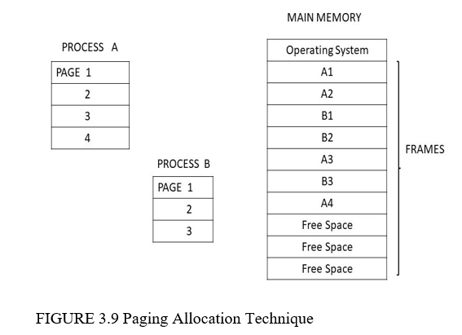

# What is virtual memory? State benefits of having virtual memory.

When a process with large size than physical memory can be executed by loading the parts of the process refers to the concept of virtual memory. It is not an existing memory but only a scheme. Sometimes the size of the data, programs and stacks may be bigger than physical memory, so the concept of virtual memory comes into picture. Only the part of the program that required execution kept into virtual memory and the rest part of the program is on the disk. The separation of user’s logical memory from physical memory is the virtual memory. When only small amount of main memory is available then, then this separation allows large amount of virtual memory for users or programmers as shown in figure 3.18

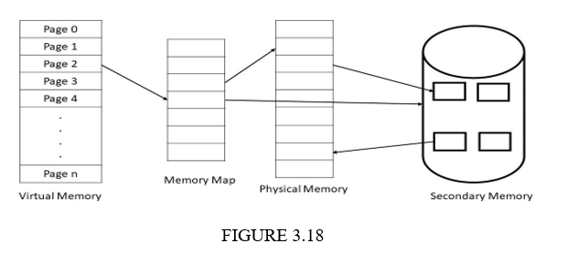

**Benefits**

* The programmer does not need to care about the physical memory, as virtual memory makes the task much easier.
* It increases the throughput and utilization of CPU.
* It reduces external fragmentation, as process can be loaded into arbitrary size space.

The processes with high priority can run faster

# Given is the reference string: 3,2,1,0,3,2,4,3,2,1,0,4 and main memory frames: 3 Calculate the total number of page faults using FIFO page replacement. (refer class notes for solution)

# What is a file? List and explain various file operations?

A collection of related data and information stored on secondary memory such as optical disks, magnetic disks and magnetic tapes is known as a file. Many different types of information can be stored in a file like text, images, graphics, codes, numeric and so on. The meaning of the data in file is defined by its user or file’s creator. A file is a series of bits, bytes, lines or records.

**File Operations**

There are some operations that can be performed on files to defined them properly. Different operating systems provide different operations to store and fetch the data or information. The following are some common operations of files:

**Creating a file: -** First find a space for the file and then new file is created in the directory.

**Writing a file: -** The pointer must be at the location where next file is to be written.

**Reading a file: -** System call is used to read a file; it identifies the name of the file and specifies the next block of the file should be place.

**Appending a file: -** This operation can add the data to the end of an existing file.

**Repositioning within a file: -** This is also called seek operation. In this current-file-position is given value and search for appropriate entry.

**Truncating a file: -** This is used to remove the contents of the files without deleting its attributes.

**Copying the file: -** This operation is used to create a copy of file and reading from old file and writing to the new file.

**Open: -** The purpose of this operation is to fetch the lists and attributes of disk into main memory. A process must open a file before using it.

**Close: -** To free up the internal space, the file must close after it finishes all its accesses.

**Renaming a file**

**Deleting a file**

# Explain disk structure with diagram.

The disk is made up from multiple platters and platters are divided into multiple tracks which are then divided into multiple sectors. The platters are accessed through head arms connected with head and can move only in two directions. All the heads move together on the platter and head is always located at same track. The set of all tracks where the head is located currently is referred as cylinder. The speed of the disk drive rotating on the disk is constant. The read/write operation is performed when head is positioned at a particular location.

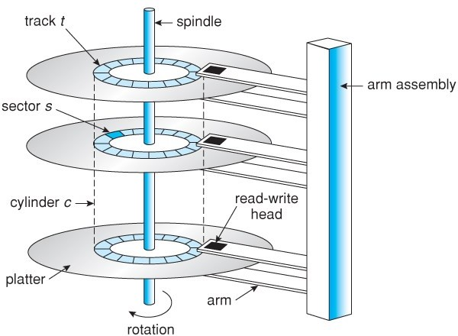

# Explain single-level and two-level directory structure.

**Single-Level Directory**: It is the simplest structure of directory. All the files kept in same directory as shown in figure

**Advantages**

• Easy to understand.

• Easy to support.

**Disadvantages**

• Same names of files can create confusion.

• Same name of different files can collide.

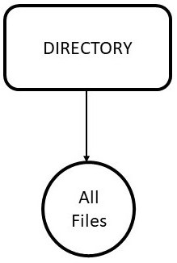

**Two-level directory** structure enables the usage of the same file name across several user directories. There is a single master file directory that contains individual directories for each single user files directory. At the second level, there is a separate directory for each user, which contains a collection of users' files. The mechanism prevents a user from accessing another user's directory without their authorization.

**Advantages**:

* In a two-level directory, a full path like user-name/directory-name can be given.
* Different users can have the same directory as well as the file name.
* Searching files becomes easier.

**Disadvantages**:

* One user cannot share a file with another user in a two-level directory without permission.
* The two-level directory also has the problem of not being scalable.

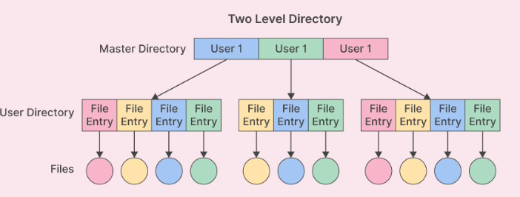

# Write a short note on segmentation.

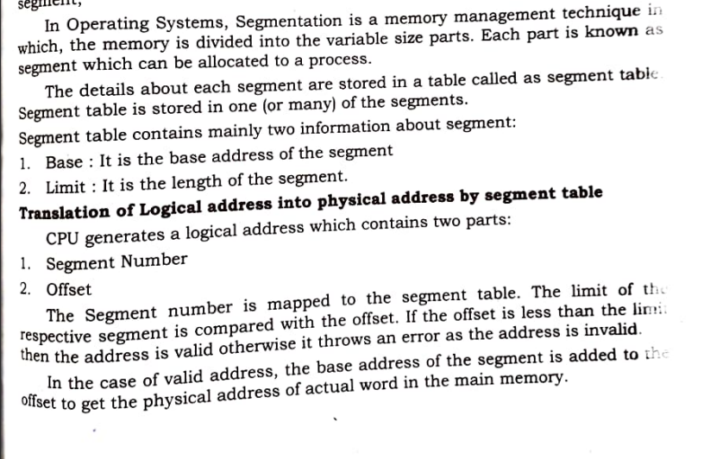

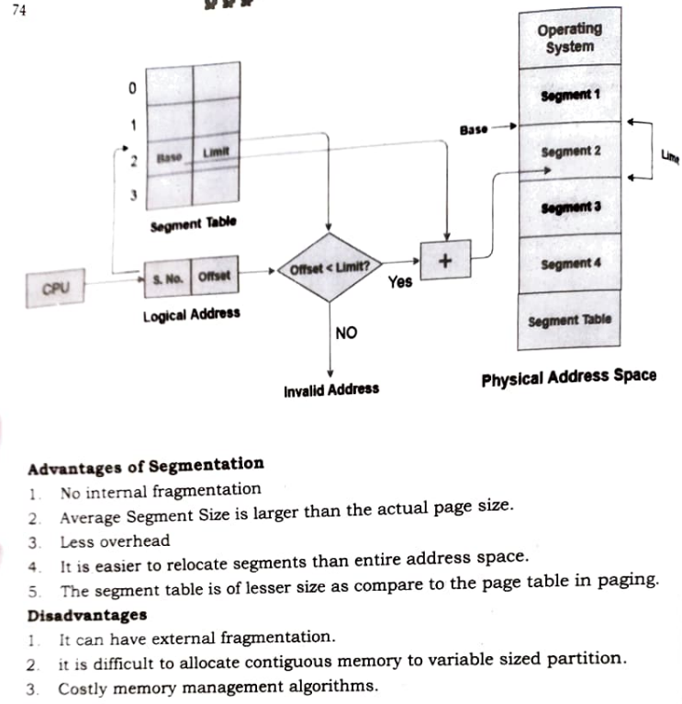

# Define file system? What are the types of file allocation methods? OR

Describe contiguous allocation, linked allocation, indexed allocation. OR

Discuss Contiguous File Allocation Mechanism with its advantages and disadvantages.

Operating system design deals with how the files are structured, used, accessed, named and implemented. That part of operating system which deals with files is known as **file system**.

The allocation methods are used so that files can be accessed easily and disk space can be utilized effectively. The following are the three methods of allocating files on disk:

**Contiguous Allocation**

* + In contiguous allocation method, all blocks of files are kept in continuous manner on the disk.
  + Its speed is fast because disk head requires no movements.
  + The file is defined by the length of first block and the disk address.
  + The problem in continuous allocation occurs when data of any file is extended or size of the file is not known beforehand.

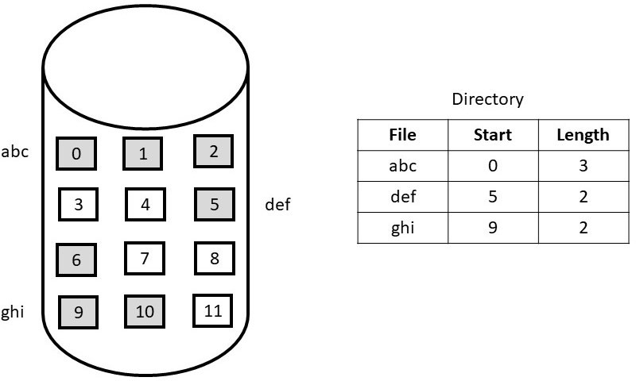So, there can be a problem of external and internal fragmentation

The advantage of contiguous file allocation is that it provides fast access to files, as the operating system only needs to remember the starting address of the file. When a user requests access to a file, the operating system can quickly locate the file's starting address and read the entire file sequentially. This method is particularly useful for large files, such as video or audio files, which can be accessed more quickly when stored in contiguous blocks.

However, contiguous file allocation has some limitations. One significant disadvantage is that it can lead to fragmentation when files are deleted or when new files are created. If a file is deleted, the space it occupied becomes free, but that space may not be contiguous with the remaining free space on the disk. This can result in gaps or fragments of free space scattered throughout the disk, making it difficult for the operating system to find contiguous blocks of free space for new files.

**Linked allocation**

* In linked allocation method, files on disks can be stored as linked list.
* It does not involve external fragmentation; it allows the size of file to grow dynamically.
* Linked allocation is only effective with sequential access files.
* Internal fragmentation occurs in linked allocation, as the allocating blocks lessen the space wasted by pointers.
* Linked allocation is not reliable, if the link is damaged.

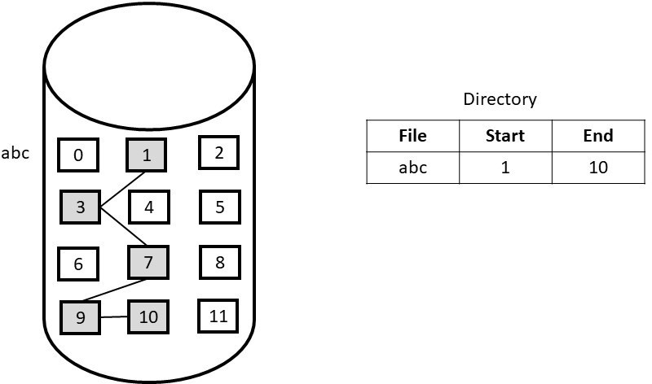

#### Indexed or i-node Allocation

* It combines all the indexes of files into a single block for accessing.
* The whole block is given to each file so, some space is wasted.
* **Linked scheme:** One disk block is an index block and single disk operation is enough for read and write. The first block contains block address, header information or may be a pointer.

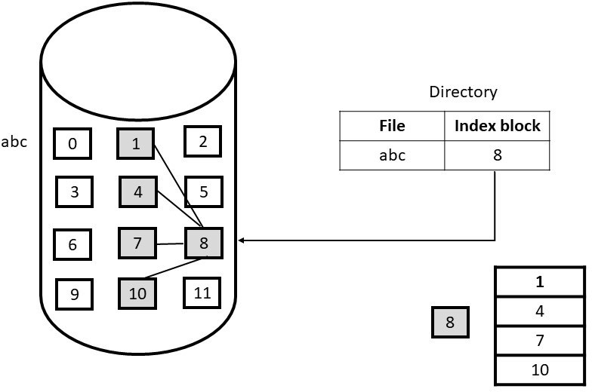

* **Multi-level index**: The first index block contains pointers to next index blocks, which then refer to actual data blocks.
* **Combined scheme**: in this scheme some pointers are directly store in i-node and it provide access to more data blocks as required.

1. **State and explain different attributes of file. OR**

**What is a file? list & explain different attributes of a file**

When a file is created, a lot of information regarding the file is created like its name, date of creation, size and so on. These items are called **file’s attributes**. The following are some of the file attributes which varies from system to system:

**a)File name:** - A file name is referred by its name and created for the convenience of its users. It is a string of characters like “name.c”.

The rules for the file name depend upon the operating system.

* + - 1. **File Size: -** The size of the file can be in bytes, words or blocks.
      2. **File Type: -** This attribute is needed where system supports different file types.
      3. **Location:** - This attribute stores the location of the file where it is stored in secondary storage.
      4. **Access Rights: -** This attribute stores the information of how the file can be accessed and who can access the file.
      5. **Time, Date and identification: -** This attribute stores the information about the creation of file, last modification and last use. This can be useful for the protection and security of files.

1. **Write a short note on Acyclic graph directory and tree structured directory. OR**

**Explain tree level directory structure in detail.**

**Acyclic Graph Structure:** In tree-structure, sharing of files and directories not allowed. This graph structure allows to share files and subdirectories as shown in figure. Acyclic graph means a graph with no cycles. The same file name and subdirectory name can be in different directories.

#### Advantages

* It is more flexible.
* Common subdirectory can be shared.

#### Disadvantages

* This structure is more complex.
* It has traverse and deletion problem.

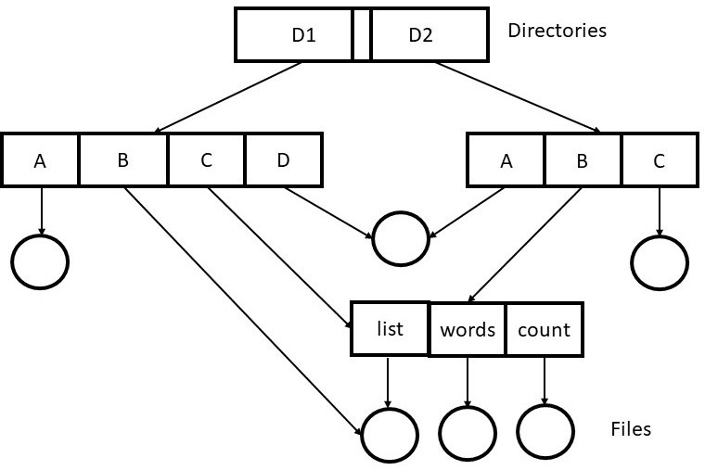

**Tree structured directory** This directory structure allows the users to create their own sub directories and they can organize file accordingly. It has a root directory. All the files have unique names. A directory contains files and subdirectories as shown in figure 5.10. Internal format of all the directories is same. Bit 0 defines the file and 1 defines the subdirectory. Directories can be created and deleted through system calls. Example is UNIX file system.

**Advantages**

* It has grouping capability.
* Users can access other user’s files through path name.

#### Disadvantages

* Structure is very complicated.
* Directory deletion is difficult

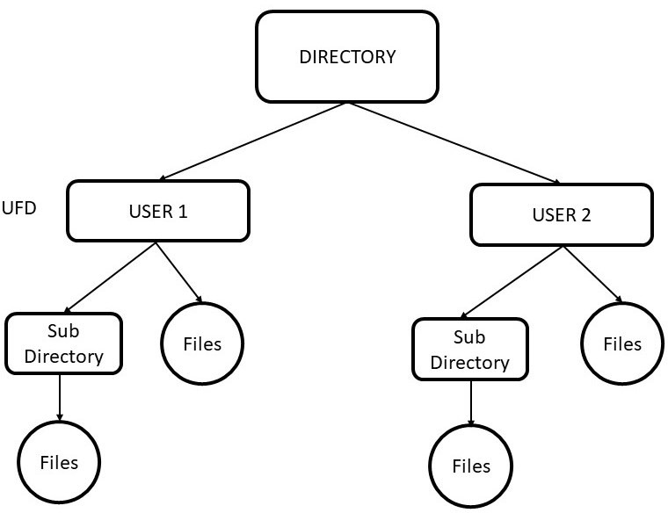

1. **Consider the following reference string: 7,0,1,2,0,3,0,4,2,3,0,3,2,1,2,0,1,7,0,1 and frame size :3**

**Calculate the total number of page faults using LRU page replacement algorithm.**

**REFER CLASS NOTES**

1. **What is free space management? Describe various implementation strategies. OR**

**Explain any two free space management methods with its advantages & disadvantages.**

Free-space management means to monitor the free disk space. Free-space list keeps records of free disk blocks so that the space can be allocated to required file or directory. When any file is removed or deleted,then that space is added to the free-space list. If any space is used then it removed from the list. The following are some approaches how it is implemented:

#### Bit Vector

* + It is a simple approach to use, in this each bit shows s disk block, set to 0 if allocated and 1 if it is free.
  + For quickly finding continues blocks fast algorithms are used.

**Advantages**

The advantages of the bit vector method are-

* It is simple to understand.
* It is an efficient method.
* It occupies less memory.

**Disadvantages**

The disadvantages of the bit vector method are-

* For finding a free block, the operating system may need to search the entire bit vector.
* To detect the first 1 in a word that is not 0 using this method, special hardware support is needed.
* Keeping the bit vector in the main memory is possible for smaller disks but not for larger ones.

#### Linked List

* + Linked list is also used to manage free blocks.
  + The File allocation table contains all the records of free blocks.

### Advantages

The advantages of the linked list method are-

* External fragmentation is prevented by linked list allocation. As opposed to contiguous allocation, this prevents the wasting of memory blocks.
* It is also quite simple to make our file bigger. All we have to do is link a new file block to our linked list. The file can so expand as long as memory blocks are available.
* Since the directory only needs to hold the starting and ending pointers of the file, linked list allocation places less strain on it.

### Disadvantages

The disadvantages of the linked list method are-

* This method is inefficient since we need to read each block to traverse the list, which takes more I/O time.
* There is an overhead in maintaining the pointer.
* There is no provision for random or direct memory access in linked list allocation.

#### 

**Grouping :**

* + The free list stores the addresses of k (say) blocks in first free block.
  + First k-1 blocks are free and last block contains data of another free k blocks.
  + Addresses can be found easily.

### Advantages

The advantages of the grouping method are-

* The addresses of a large number of free blocks can be found quickly.
* This method has the benefit of making it simple to locate the addresses of a collection of empty disk blocks.
* It's a modification of the free list approach. So, there is no need to traverse the whole list.

### Disadvantages

The advantages of the grouping method are-

* The space of one block is wasted in storing addresses. Since the nth block is used to store the addresses of next n free blocks.
* We only save the address of the first free block since we are unable to maintain a list of all n free disk addresses.
* There is an overhead in maintaining the index of blocks.

#### Counting

* + Sometimes there are continues free block, so to keep track of this just store the addresses of first block and the last block.
  + These can be stored in a B-tree rather than linked lists.

### Advantages

The advantages of the counting method are-

* Fast allocation of a large number of consecutive free blocks.
* Random access to the free block is possible.
* The overall list is smaller in size.

### Disadvantages

The disadvantages of the counting method are-

* Each free block requires more space for keeping the count in the disk.
* For efficient insertion, deletion, and traversal operations. We need to store the entries in B-tree.
* The entire area is reduced.

1. **Write a short note on thrashing.**

Sometimes the memory is full with pages and no free space left for new required pages then the page fault occurs. Even after swapping the pages, page fault can be occurring continuously due to the swapped-out page required for the execution. This situation is called **thrashing** where system is continuously processing page faults and executing instructions.

Methods to Handle Thrashing

The following are some methods to handle thrashing:

**Local replacement algorithm: -** By using local replacement algorithm, the process swaps the page which belongs to same process and it does not take frames form another process. So that the process can execute properly.

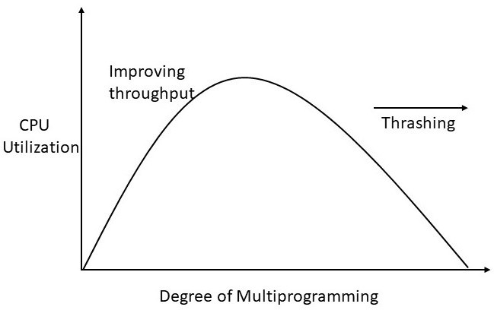

**Allocating frames to process as required: -** If a process have as many frames it requires, then the thrashing can be prevented. There are several techniques to do this. **Working-set model** is one of them. It is based on locality. It is a collection of pages referred by process at a recent interval of time.

**Controlling the page-fault frequency: -** Another method to handle the thrashing is by controlling the page-fault frequency. It can be controlled by establishing upper and lower bounds on the desired page faults as shown in figure. If the page fault exceeds upper limit, allocate more frames and if it is below than lower limit, remove the extra frames

1. **Define Page fault and Page hit. Draw graph and calculate total number of page faults and page hits using LRU page replacement method for the following string.**

**Number of frames allocated to a process =3;**

**String(pages): 1 2 3 4 5 2 1 3 3 2 4 5**

1. **Explain what is paging memory management & with suitable diagram explain how logical to physical address mapping is done in paging.**

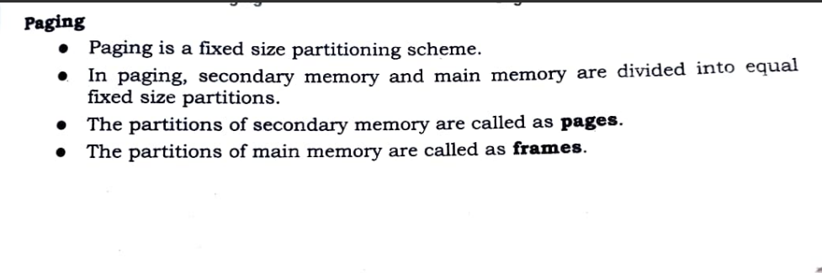

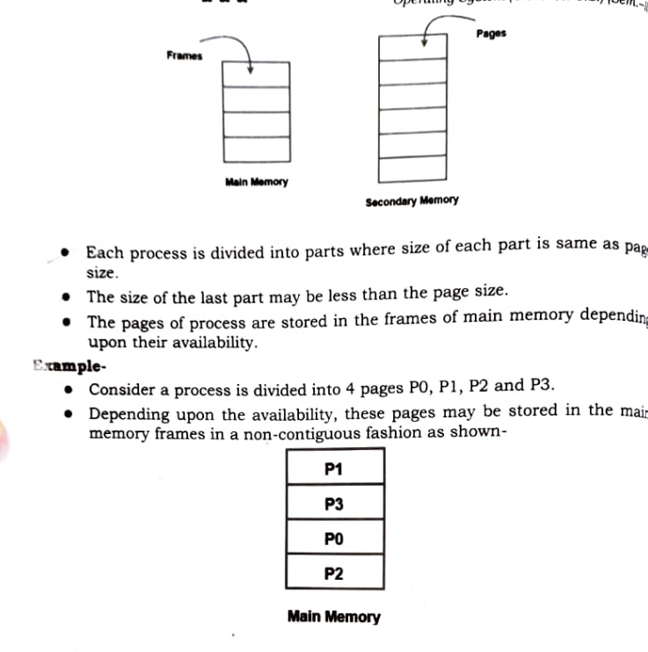

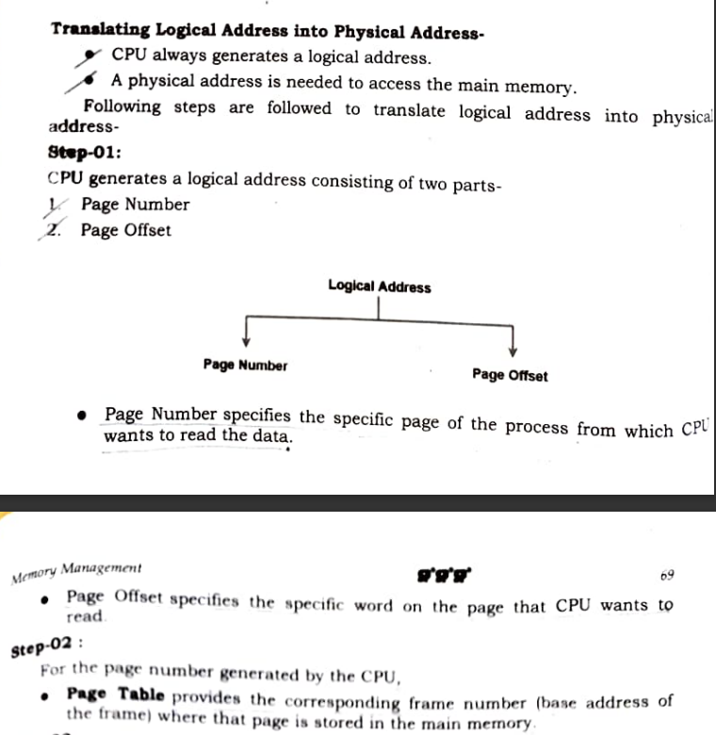

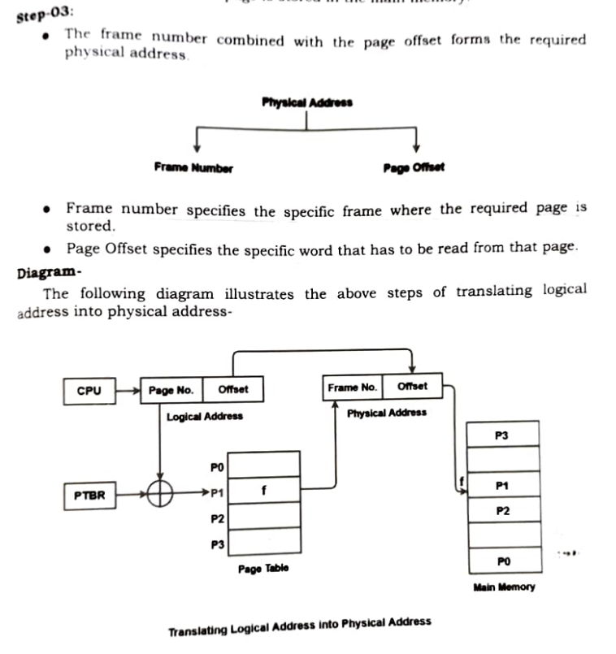

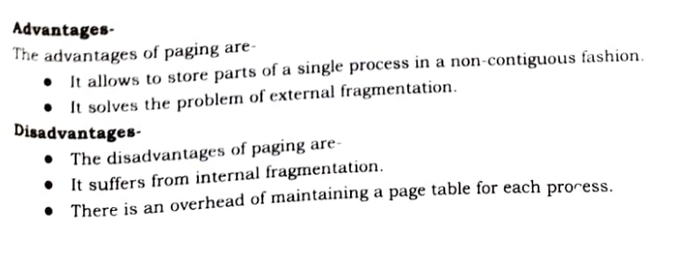

1. **What is a File System? Explain Virtual file system structure.**

Operating system design deals with how the files are structured, used, accessed, named and implemented. That part of operating system which deals with files is known as **file system.**

When a process with large size than physical memory can be executed by loading the parts of the process refers to the concept of virtual memory. It is not an existing memory but only a scheme. Sometimes the size of the data, programs and stacks may be bigger than physical memory, so the concept of virtual memory comes into picture. Only the part of the program that required execution kept into virtual memory and the rest part of the program is on the disk. The separation of user’s logical memory from physical memory is the virtual memory. When only small amount of main memory is available then, then this separation allows large amount of virtual memory for users or programmers as shown in figure 3.18

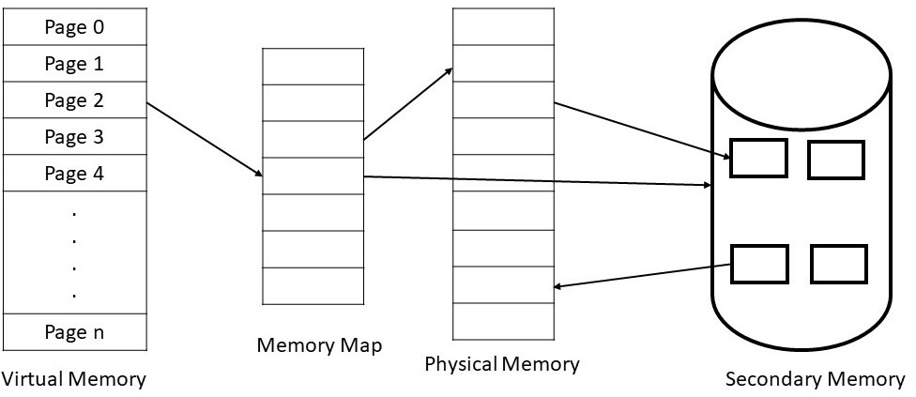

#### Advantages

* The programmer does not need to care about the physical memory, as virtual memory makes the task much easier.
* It increases the throughput and utilization of CPU.
* It reduces external fragmentation, as process can be loaded into arbitrary size space.
* The processes with high priority can run faster.

#### Disadvantages

* The systems with virtual memory are slow.
* Due to large number of paging, thrashing can be occurred.
* Additional system hardware support is required.

**18) Explain following in brief**

**1)Swapping**

A process that is currently executing must be in the main memory (RAM). The process has to be first loaded from secondary memory (hard disk) to primary memory or main memory before execution. This technique is called *process loading*. After completing the execution, it must load back to secondary storage as main memory has limited space and other processors need that space for execution. When the two processes swaps, it is called ***Swapping***. Swapping is done by the operating system. The figure shows the operation of a swapping. First there is only process P1 in main memory then process P2 is initiated and swapped in from secondary memory and P1 Swapped out to secondary storage

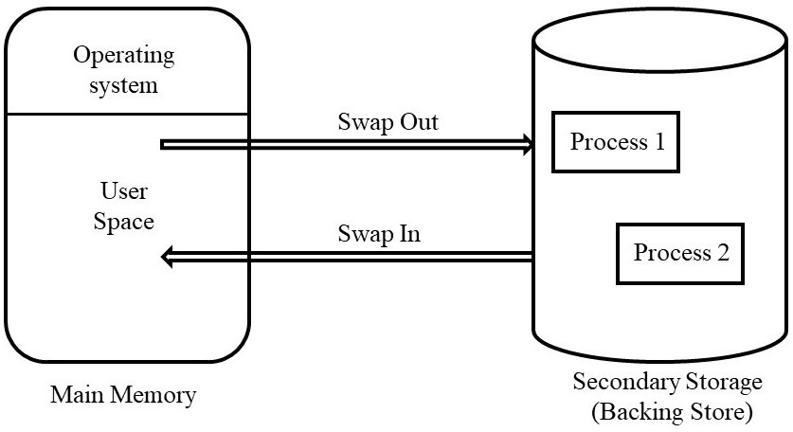

**2)Virtual paging management**

When a process with large size than physical memory can be executed by loading the parts of the process refers to the concept of virtual memory. It is not an existing memory but only a scheme. Sometimes the size of the data, programs and stacks may be bigger than physical memory, so the concept of virtual memory comes into picture. Only the part of the program that required execution kept into virtual memory and the rest part of the program is on the disk. The separation of user’s logical memory from physical memory is the virtual memory. When only small amount of main memory is available then, then this separation allows large amount of virtual memory for users or programmers as shown in figure 3.18



**Benefits**

* The programmer does not need to care about the physical memory, as virtual memory makes the task much easier.
* It increases the throughput and utilization of CPU.
* It reduces external fragmentation, as process can be loaded into arbitrary size space.

The processes with high priority can run faster

**19)Write difference between first fit, best fit and worst fit memory allocation.**

**Best Fit Policy**: - In this policy, the memory manager loads a process in the small area of memory which is unallocated and it fits. For example, in figure 3.8 there are unallocated blocks of 10KB, 14KB, 17KB, 12KB and 16KB. A process needs 11KB of memory, then the best fit policy will allocate 11KB of the 12KB block to the process. In this policy memory manager allocate the smallest hole which is big enough for the process.

**First Fit Policy**: - In this policy, memory manager allocates the first available hole to the process that is big enough for the process. To load process into the memory first fit policy allocates 14KB block for 11KB process

**Worst Fit Policy**: - The worst fit policy allocates largest hole to the process from unallocated memory available. Using same example, memory manager allocates 17KB block to 11KB process.

#### 